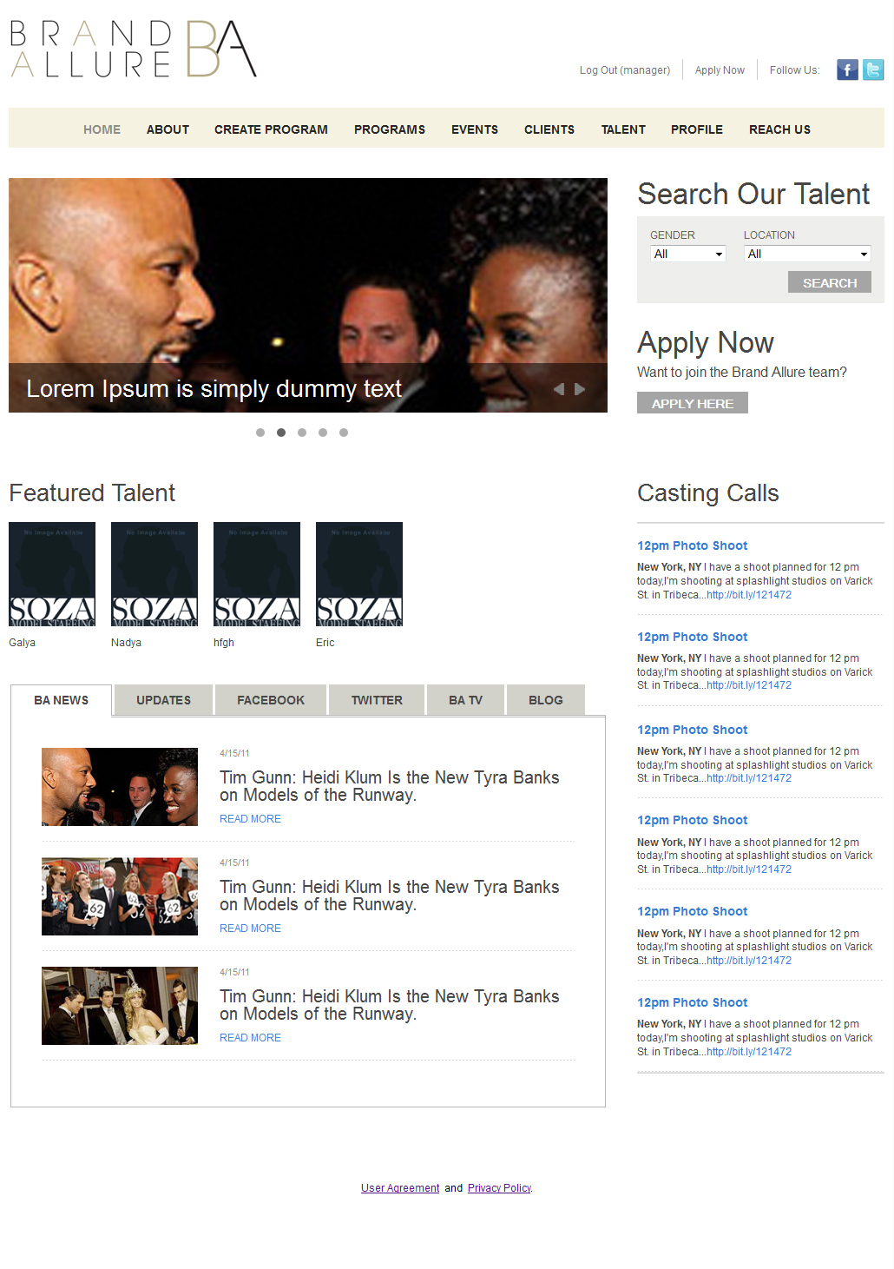The project provides 4 roles (admin, manager, client, model).

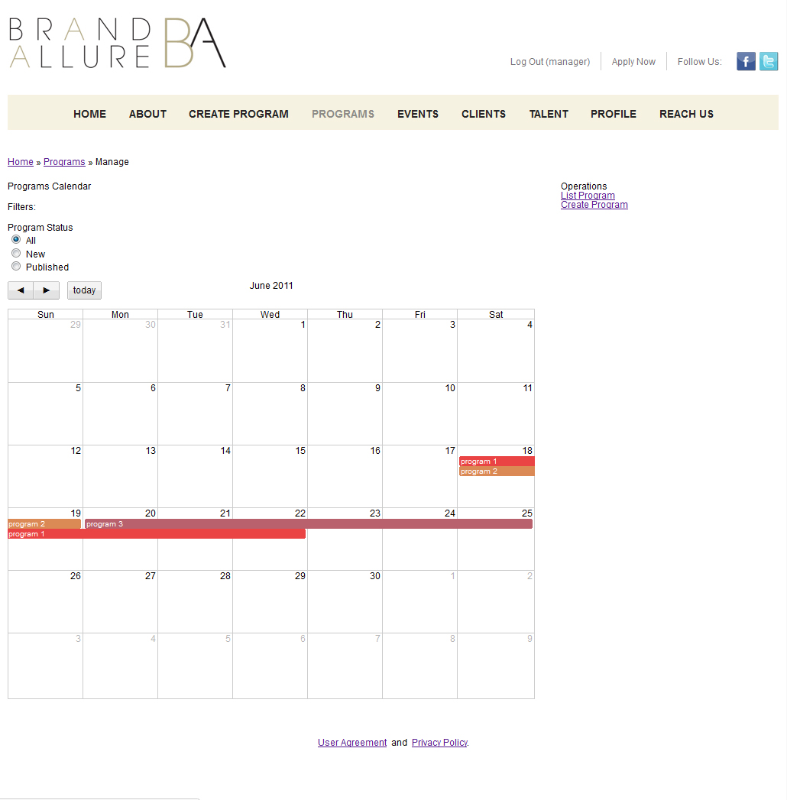
Manager can create a program that assigns the client's choice. The program has a period of one to several days. After creating a program manager has the ability to view a calendar of their programs, as well as filter them according to the status (new, published). By clicking on the program manager in the calendar to move to a page view of the program.
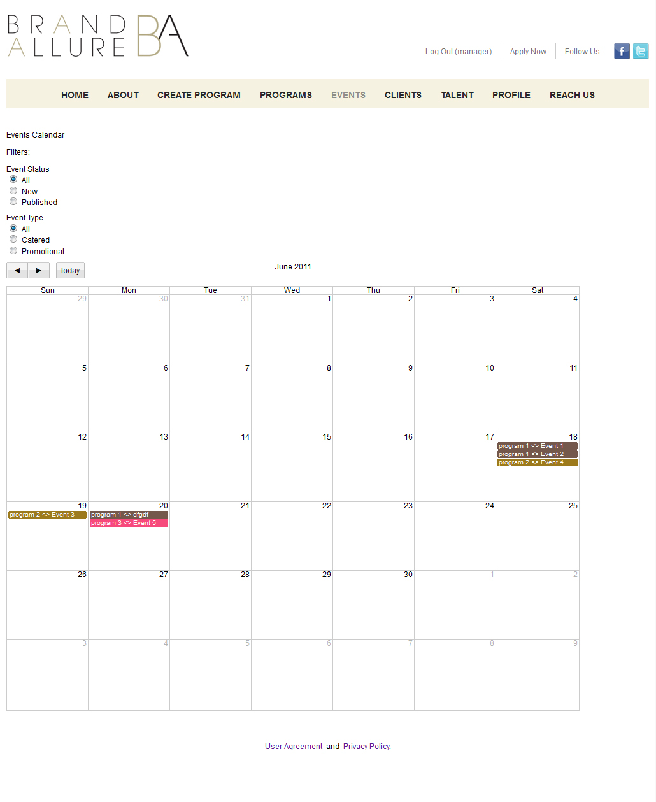
There is also a calendar of events filtered by status and type.
This page shows general information about the program. There is also manager can add to the program event (Events), to publish the program, send the client a proposal and contract. When you add an event manager turns into a wizard to create an event where the steps necessary fills all the tabs.
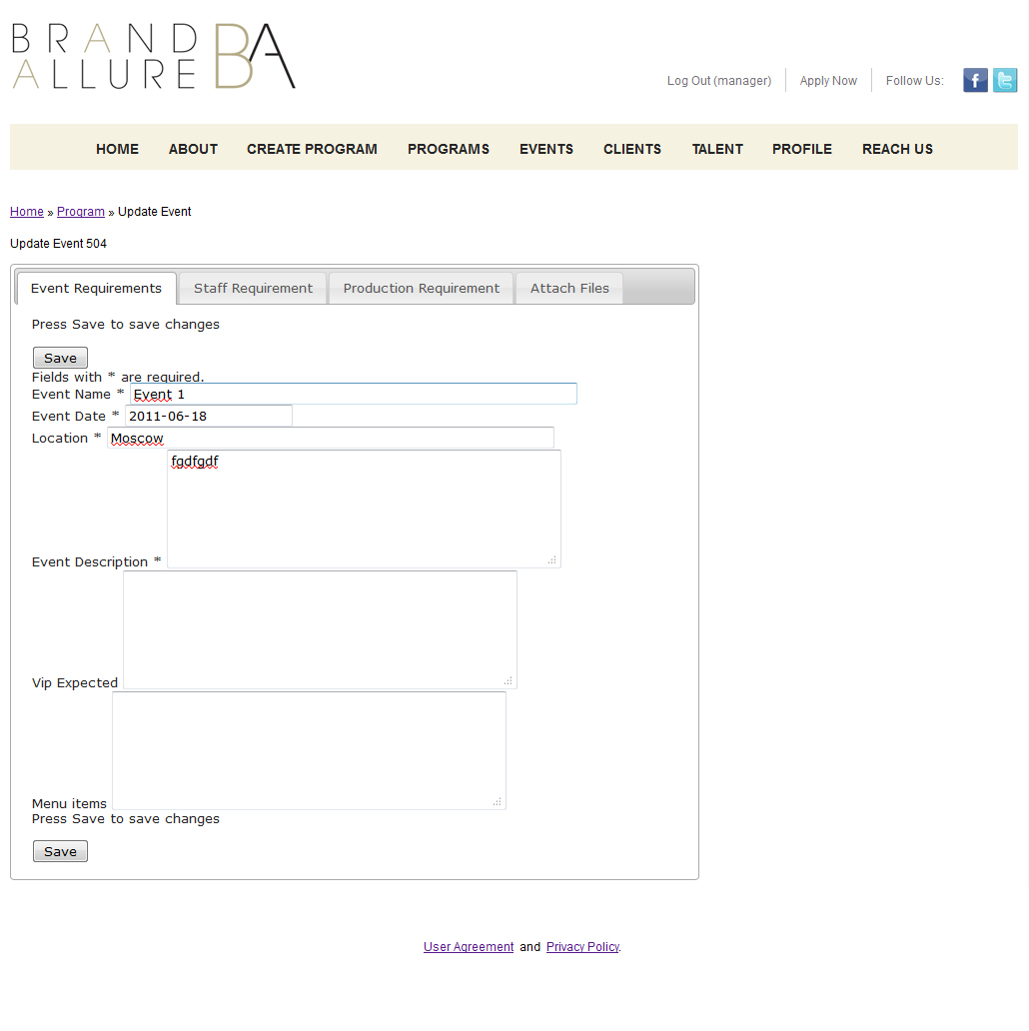
Tab, Event Requirement manager introduces general information about the event. The event lasts one day and can not go beyond the program.
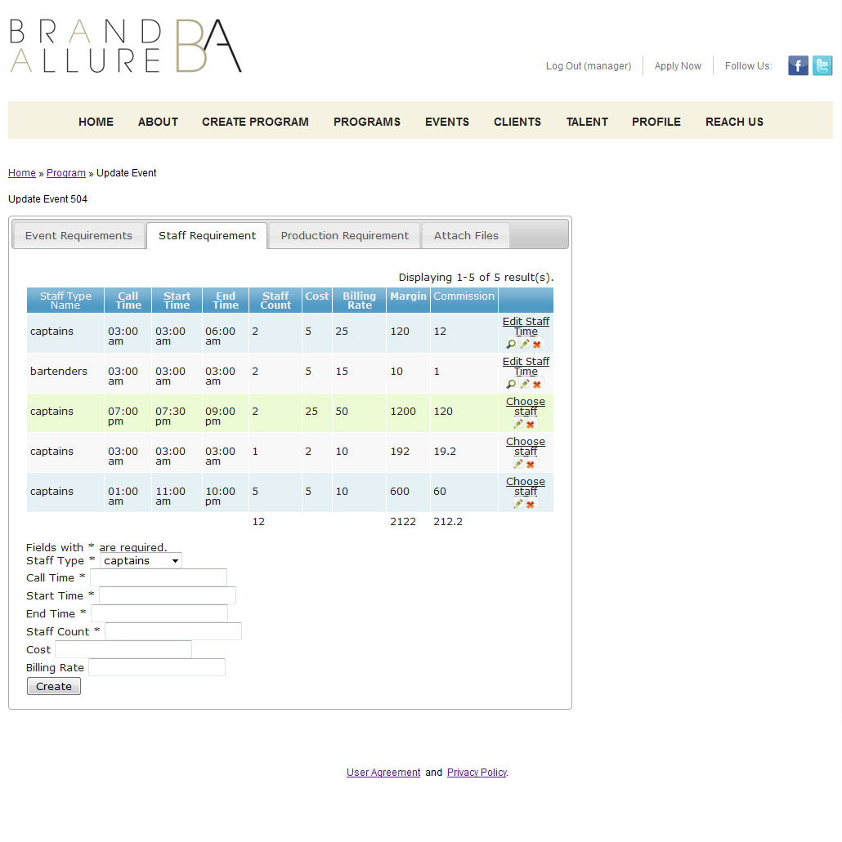
Tab, Staff Requirements manager specifies the required number of staff depending on the profession as necessary to pay staff and how much to pay the client. After adding a staff requirement also displays information about income and commission. By clicking on the link Choose staff manager to a page of recruitment.
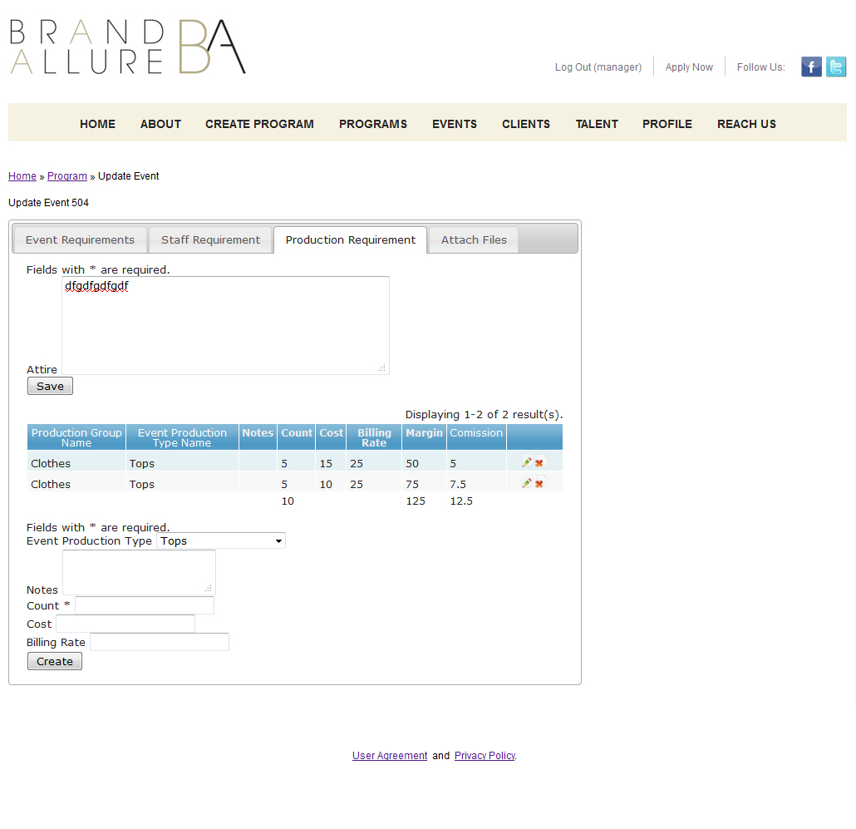
Production Requirement tab to enter information about the necessary equipment for this event.
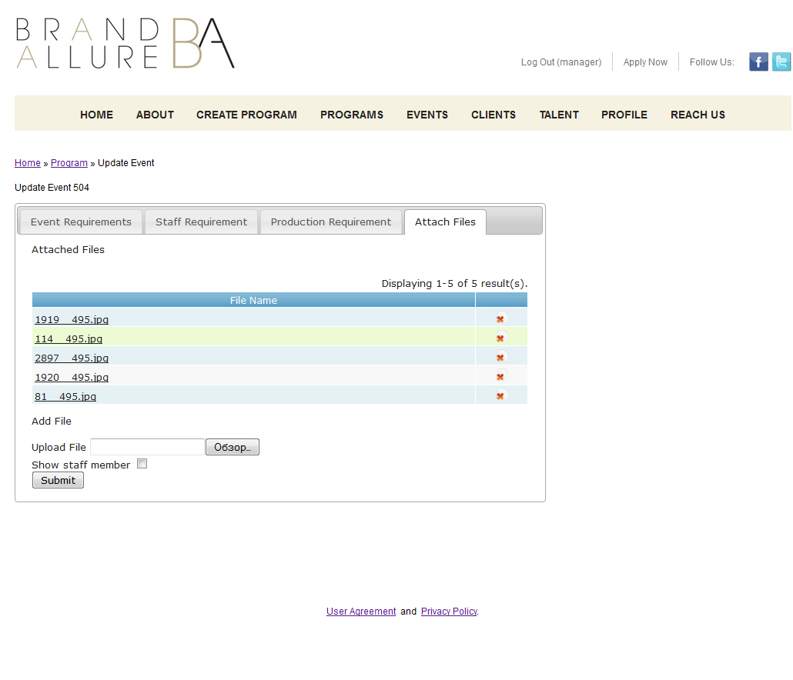
Attach Files tab, there is a possibility to attach files.
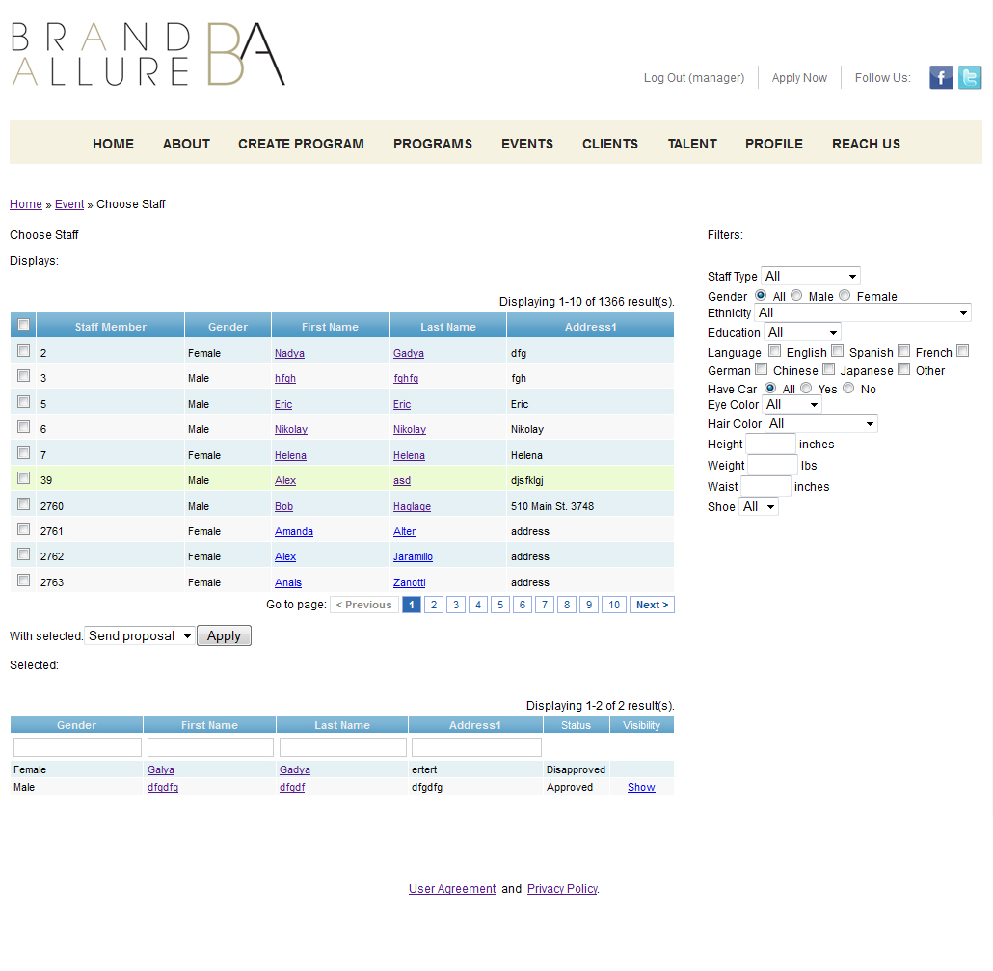
On the page there are two recruitment tables. The top displays information about all the staff members related to the job specified in the Staff Requirements tab when creating / editing an event. It is also possible to filter the entire staff (to select all the professions, gender and other parameters). Manager can select by pressing the checkbox c staff left at the table. After selecting staff and click on the Apply button to all who have been given is sent invitations to participate in the event and moved to the top of the list in the bottom of the table. At the bottom of the table displays the status for a specific party events. When the proposal was sent to the status indicated that the proposal has been sent. A participant can confirm or refuse to participate in an event that will be directly displayed in the status. If you agree to take part in the event the manager an opportunity to show the client that participant events (Column Visibility).
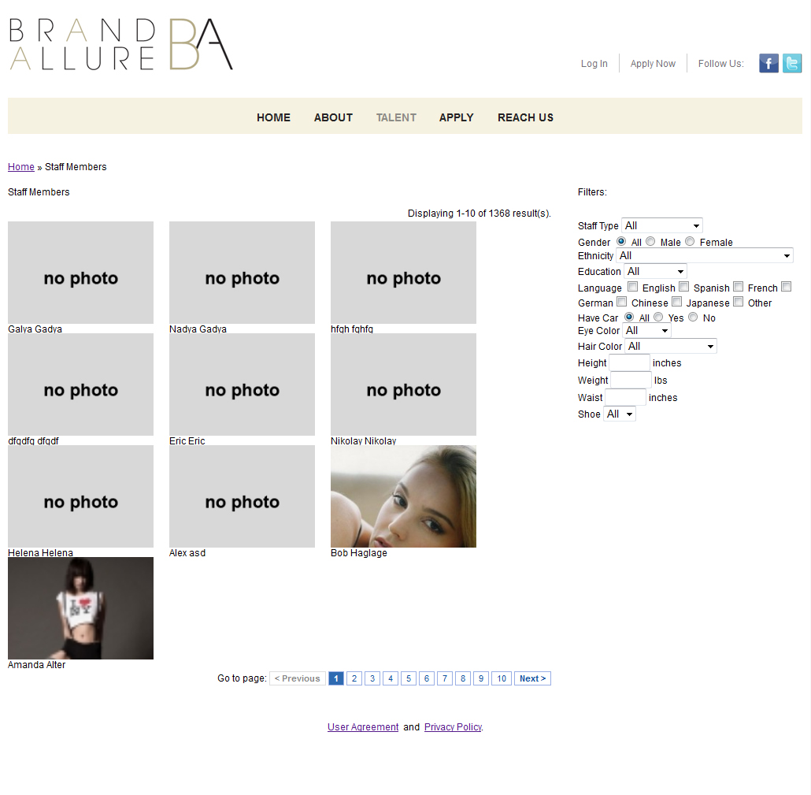
Talent page displays a list of all staff members registered on the system. It is possible to filter the list of parameters.
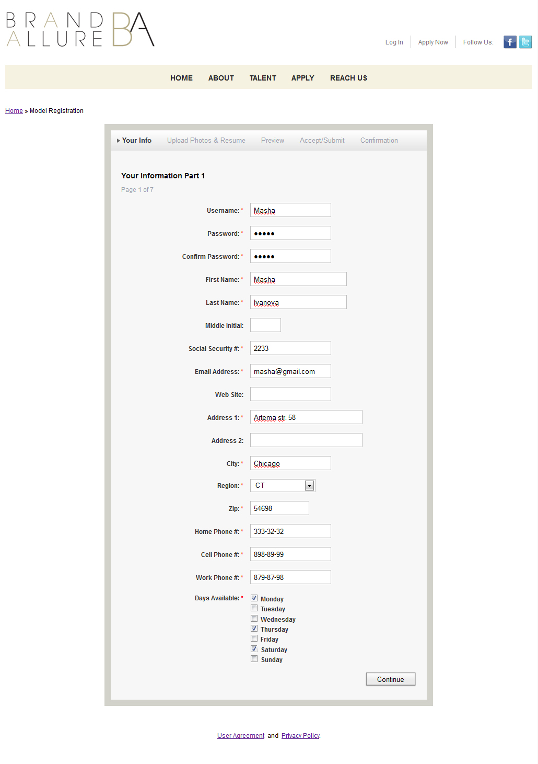
Not a registered user has the option to register as a staff member. To do this he must pass the master recording. On the first page, it fills an overview of his days, indicating that he may take part.
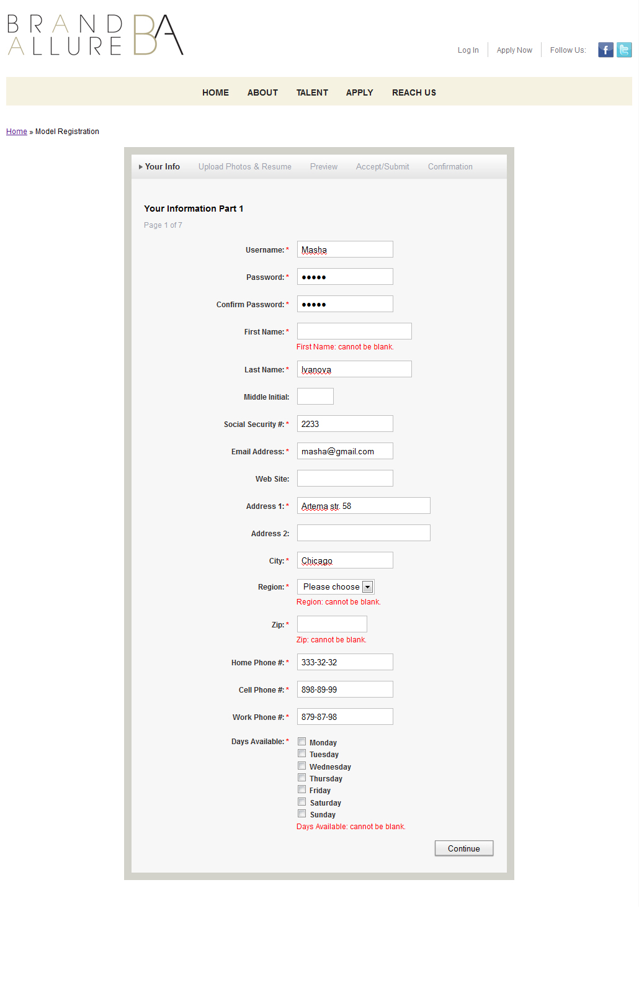

If not properly fill out the form error messages.

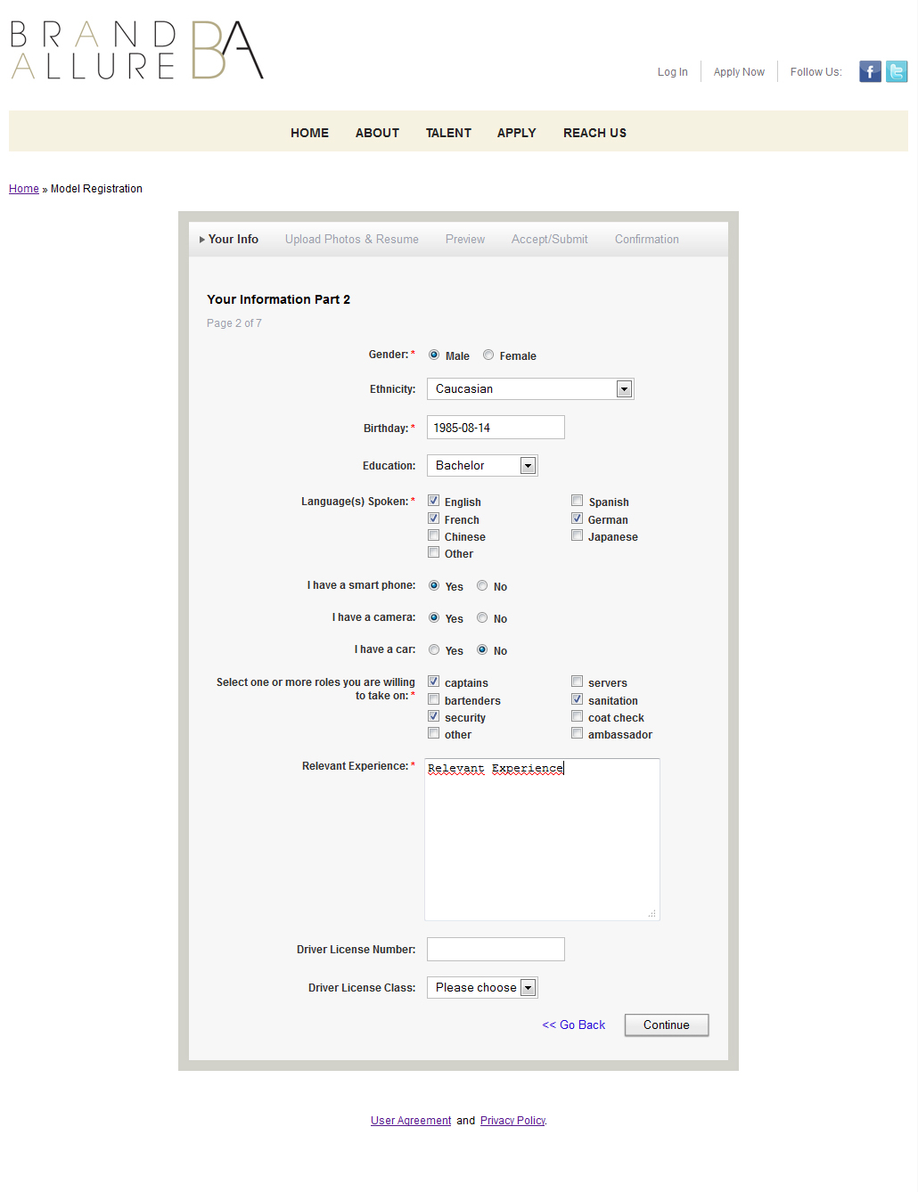The next step is chosen gender, profession, as that may be involved in events and other information.

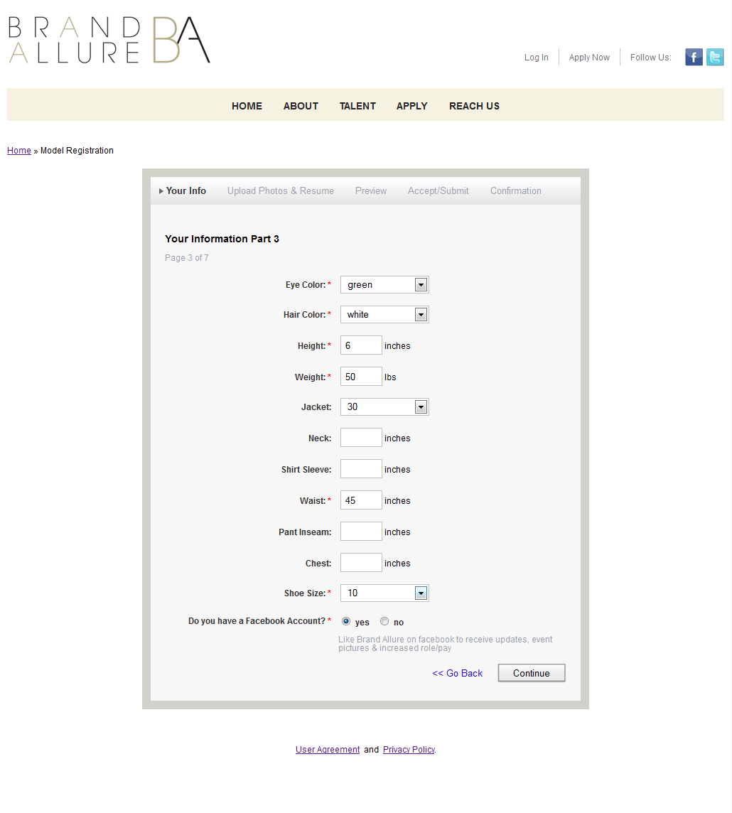In the next step depending on the sex in the previous step is filled with information about the parameters recorded.

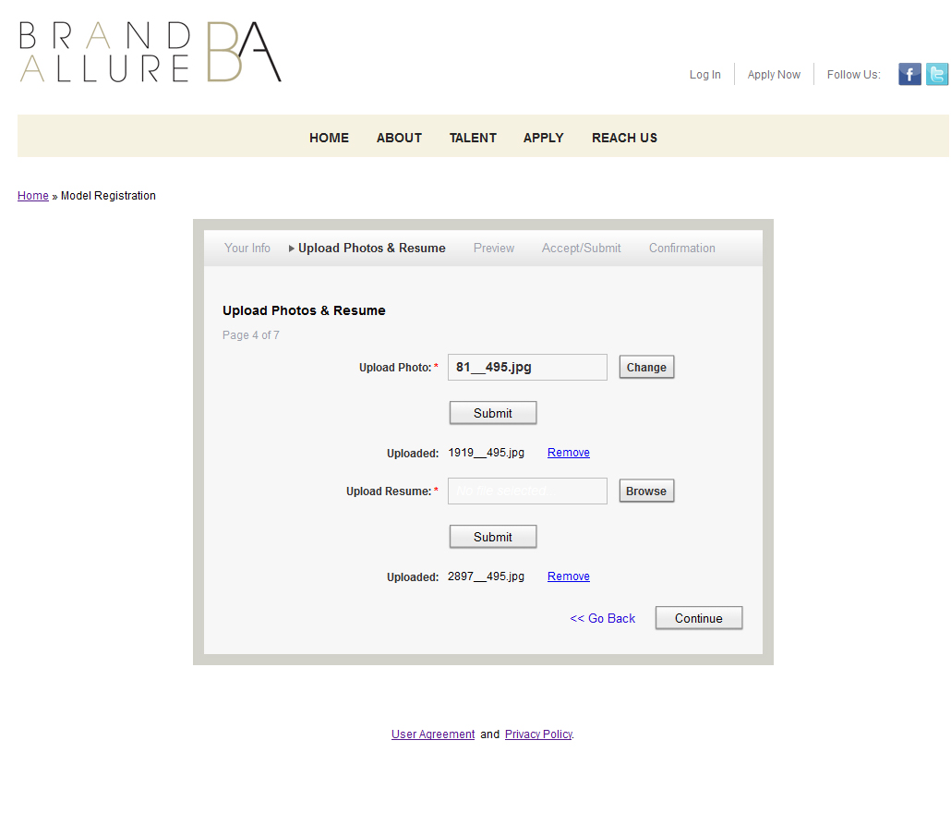
In this step, it is possible to attach a photo and resume.
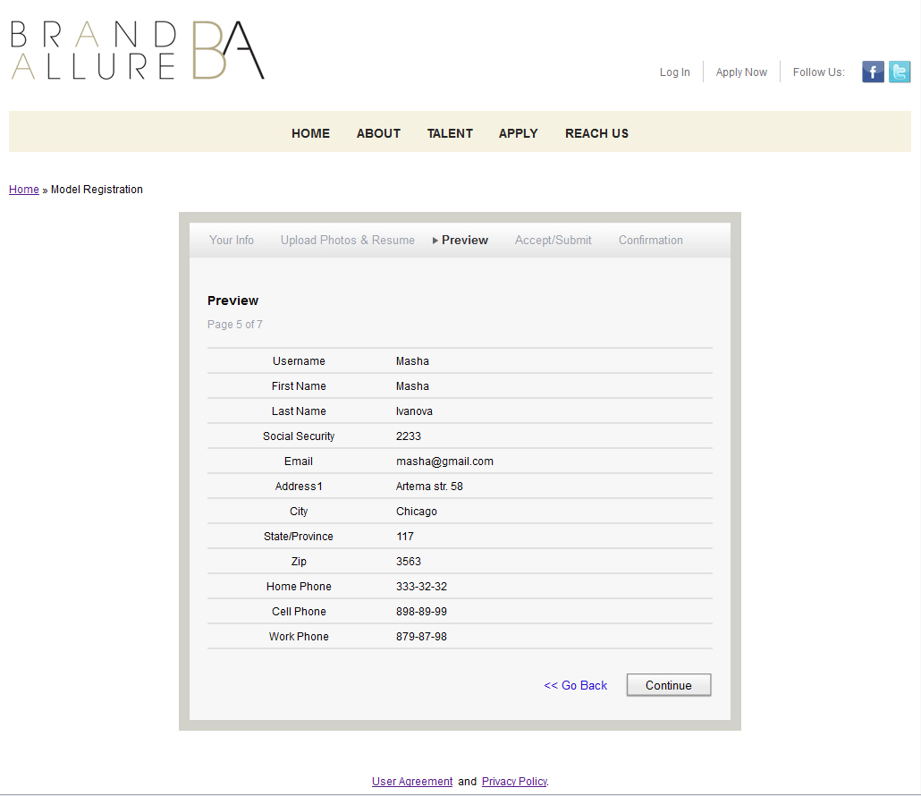
On this page (step) shows the information entered in previous steps.
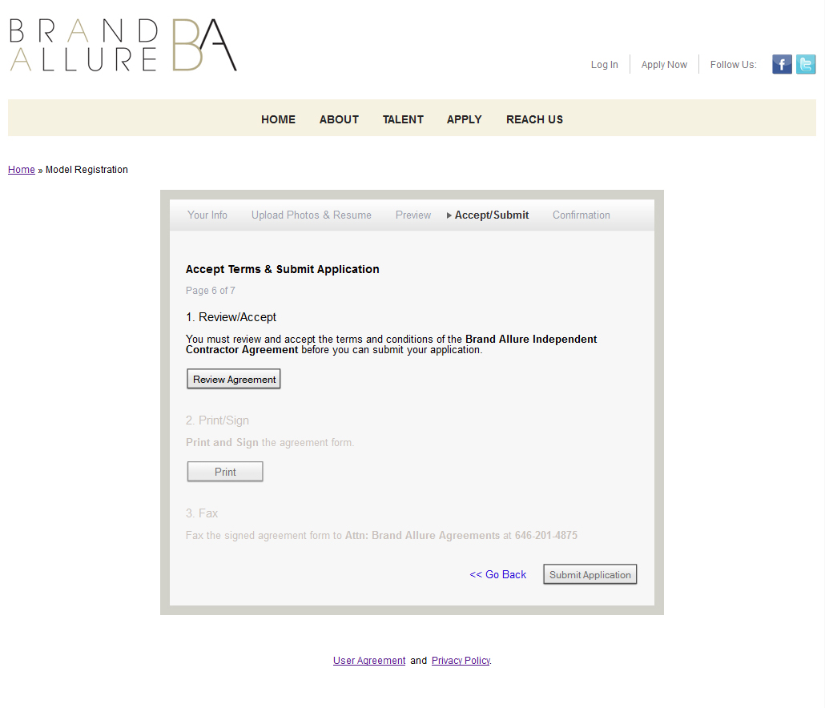After entering all necessary information, the user enters the page on which steps need to read and confirm the license agreement, the agreement to print and finally to confirm their participation in the project.
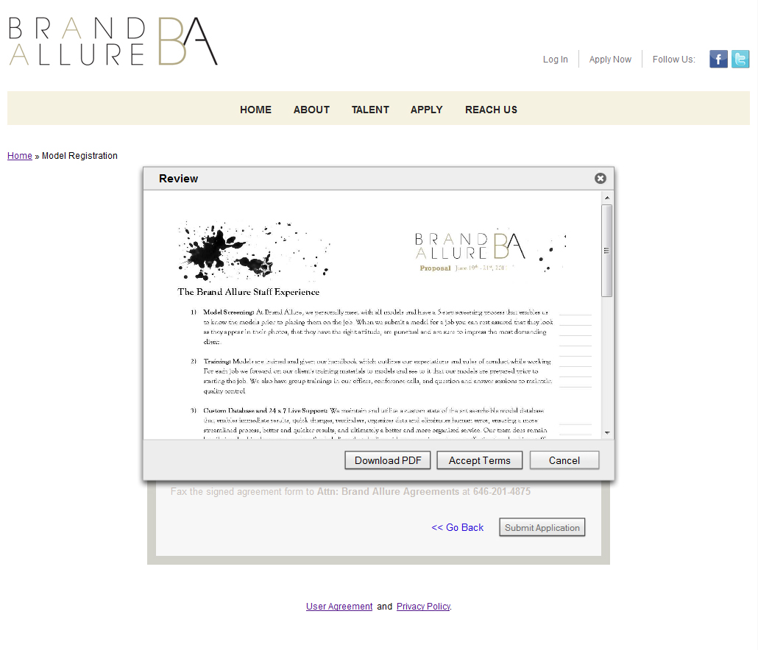
A page with a dialog box that displays the agreement. If a positive response, the user goes to the next step.
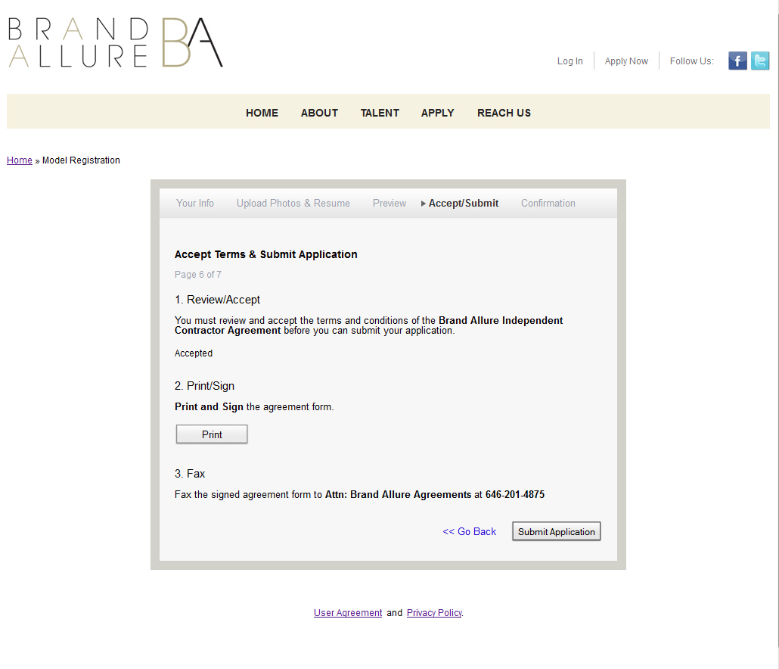
In the next step the user can print out the agreement.
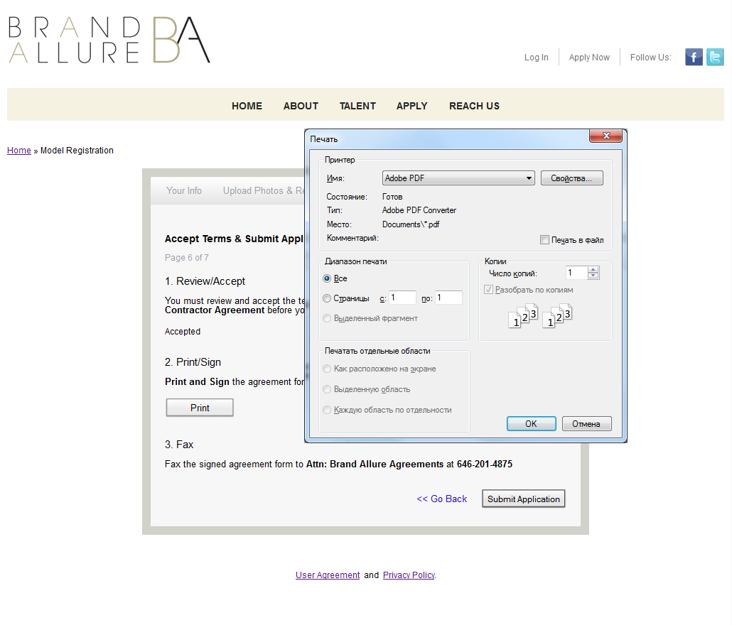After printing, the next step to become available to confirm its participation in the project.
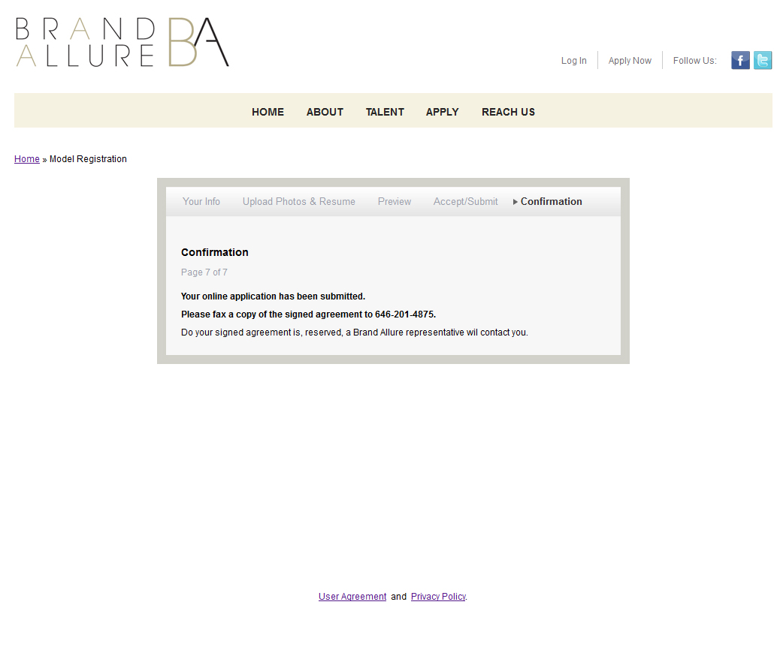On this page the user prints out that it has successfully registered.
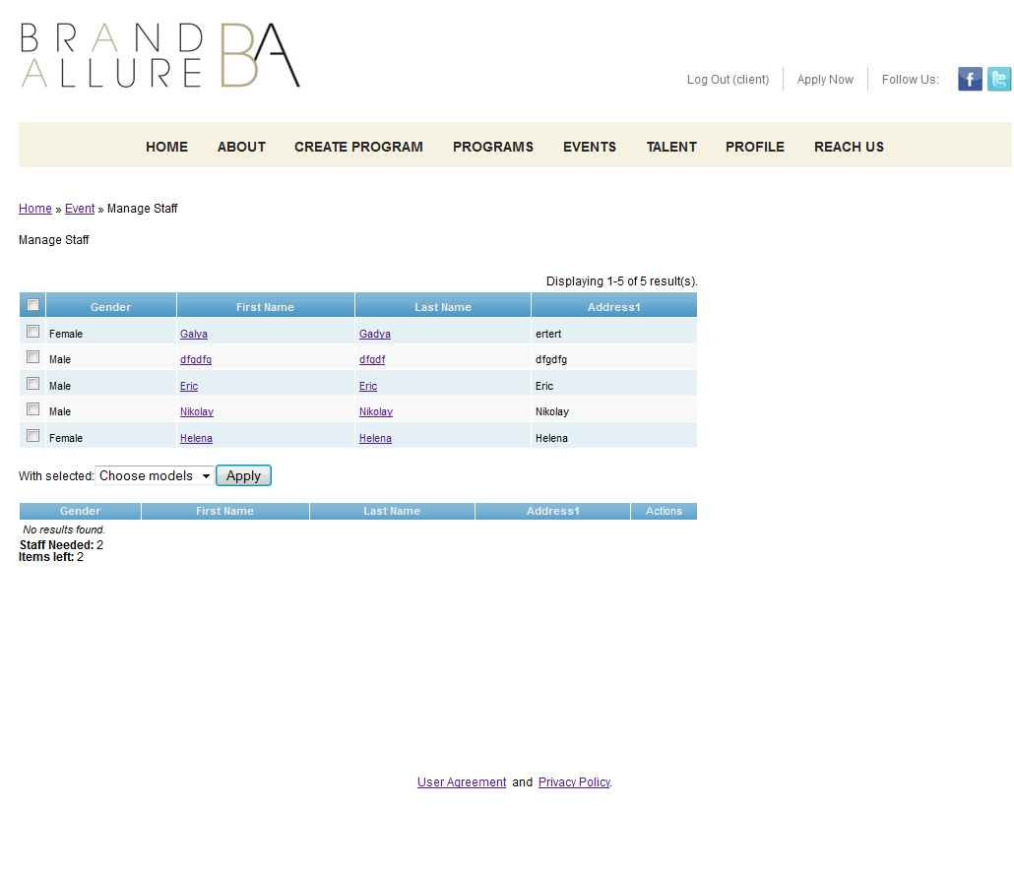
The role of the Client also has the ability to create and edit programs and events. Except for the fact that the client does not display information about profits and commissions. And when the client enters the recruitment page on which appears at the top table participants proposed a manager from which he can finally make a choice and send a confirmation by clicking on the button Apply.
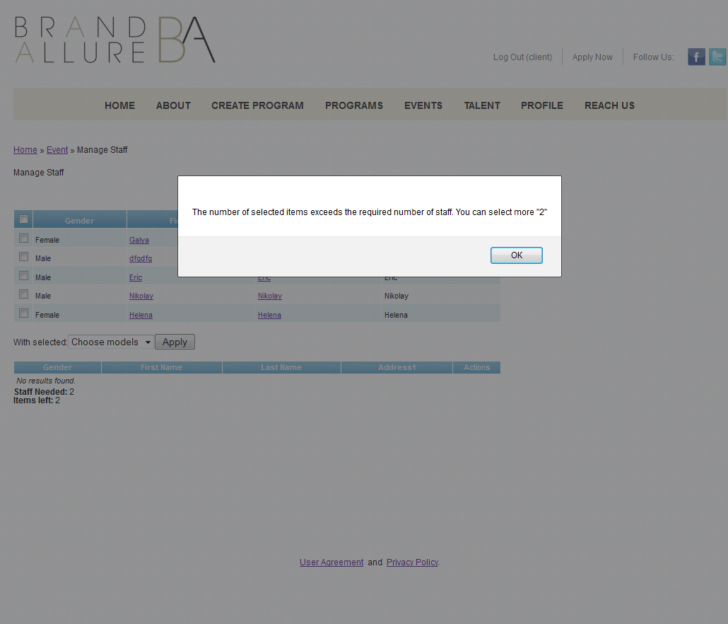
The client can not choose more than the required number of participants, as indicated by a message.
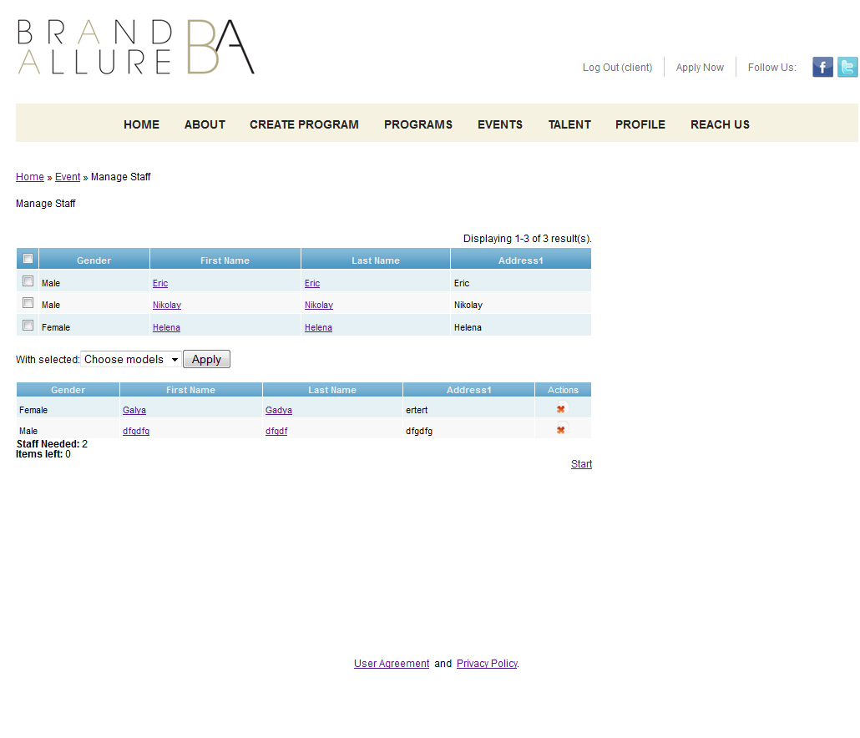
After selecting the desired number of participants, customers have the option to become the start of the event, and then lost the possibility of recruiting.
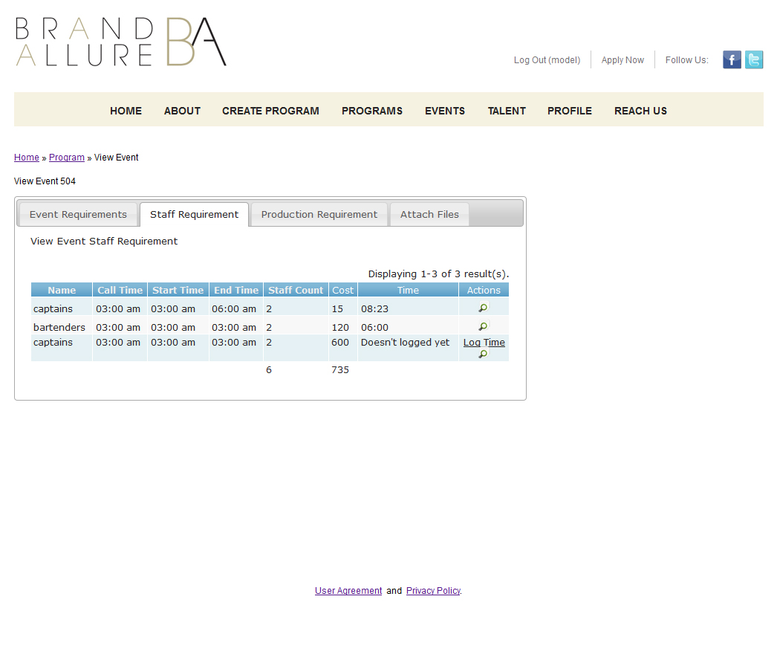
After completion of the event participant has the opportunity to specify the time he spent at the event.
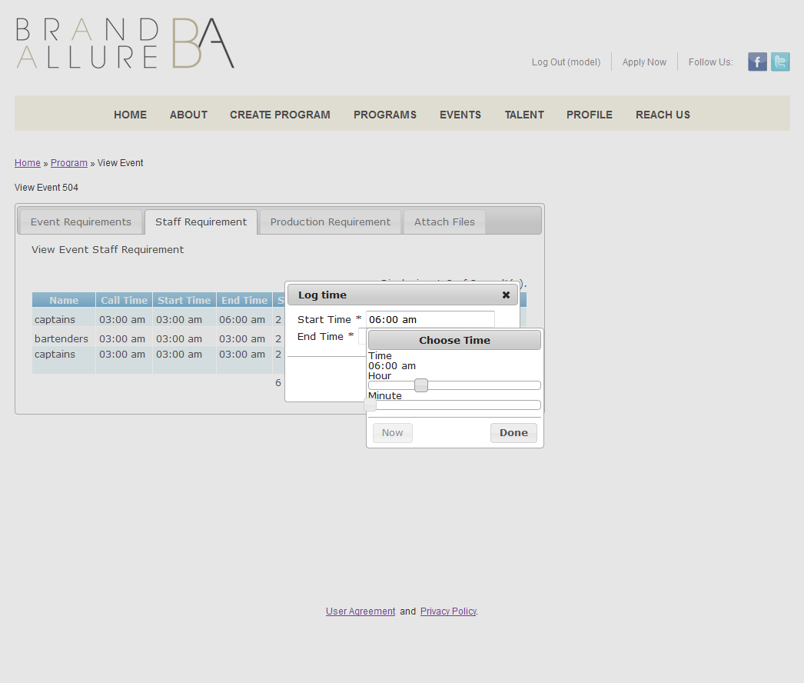
To do this he must specify the time when he came to and end time. Do managers have the opportunity to edit this time.
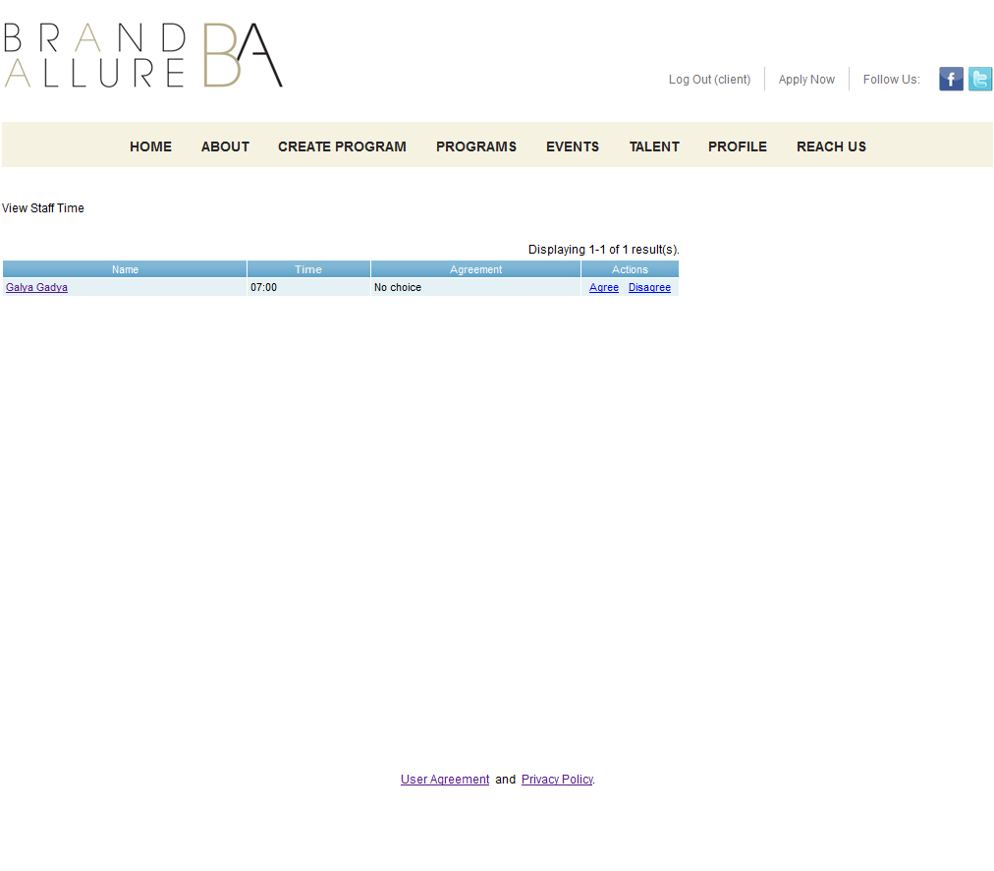
The client can either confirm or refute the involvement of time staff member.

