Social Network ALTASFERA.
Altasfera - a social network for people who can do a good job and that there must be some benefit from the others. No money and personal meetings. You just offer your services and if necessary may agree to provide services you need. Your rating depends on you and made ​​you work. More job well done, more people will want to cooperate with you.
To develop a social network are the key technologies Zend Framework and Smarty. Database - MySQL. In addition, using a number of additional libraries: PEAR, ImageMagick, and others, including own libraries.
The network is aimed at a large attendance, so early as the beginning of development were used technology to increase productivity and protection of highly loaded networks: singleton, removal of the logic in procedures and triggers, database, validate the user by using cookies, placing the downloaded files out of web-prostrans Twa, etc.
The site consists of frontenda and back-end (backend).
The first version of the network was completed in May 2011. Part of the pages listed below:
- Registration
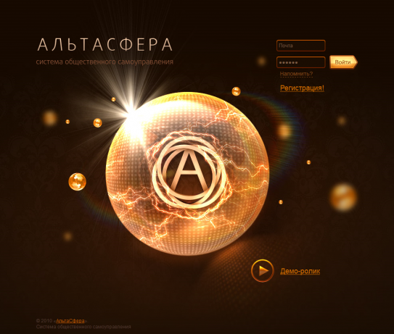
If the user is not registered, there is no reference to resource use (it turns a registered user and can be posted on the forums), then it falls to the registration page, where a pop-up window may apply to participate in the project.
2. Home user.
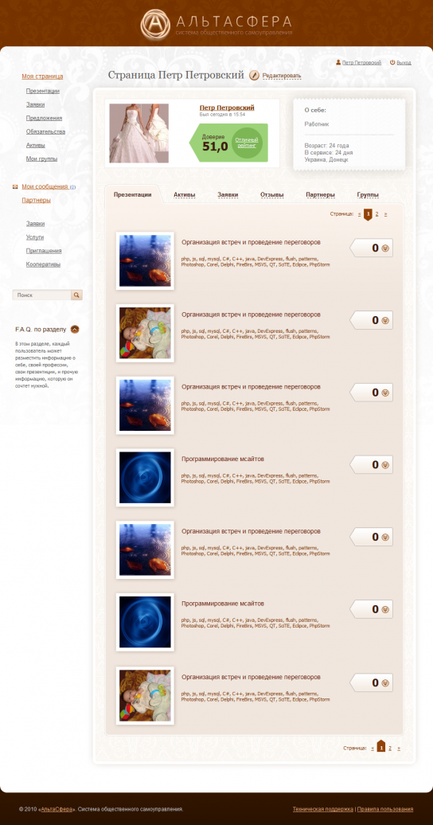
On the main project page (profile) can be traced back page structure, which is parsed into separate common elements (modules). This module of the left menu, a search engine and module FAQ.In addition, for resources, user tabs used as a modular algorithm, so the principal display, for example, presentation, and differs only in assets incoming data (models) and templates (sort of).

- Suggestions
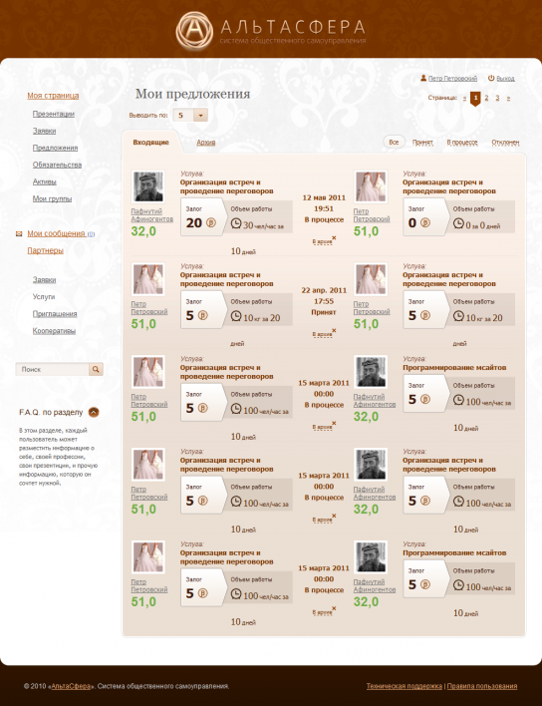
Proposals - the basis of the network. Ie user with some resources, they can share with other users. On the page, but padzhinatsii used filters and sampling. Naturally, it all works using technology AJAX.

4. Obligations.
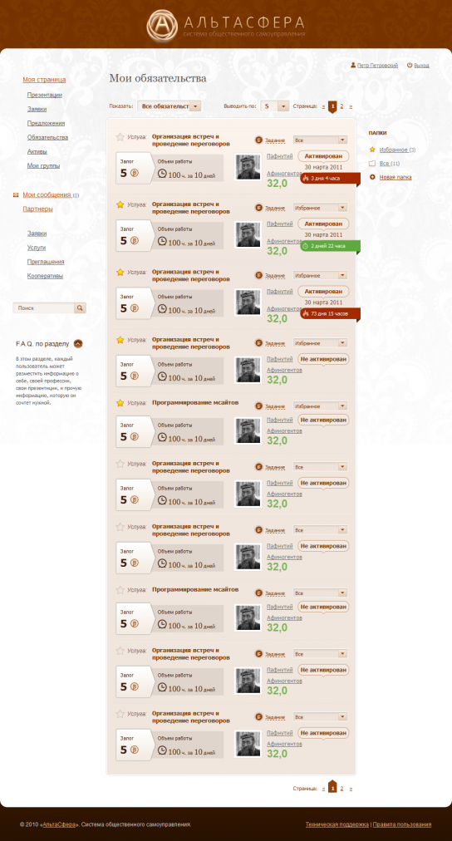
After signing the deals, the user appear assets and liabilities (what it should do). The page is additionally used functional commitment to create folders for organizing, selecting a folder to a specific obligation and commitment to the movement of your favorites. All actions are carried out using AJAX without refreshing the page, in addition to the right module folder number is updated resources. In addition to write a plugin for Smarty to display the time in the required format.
In the first phase of development of the database schema is as follows:
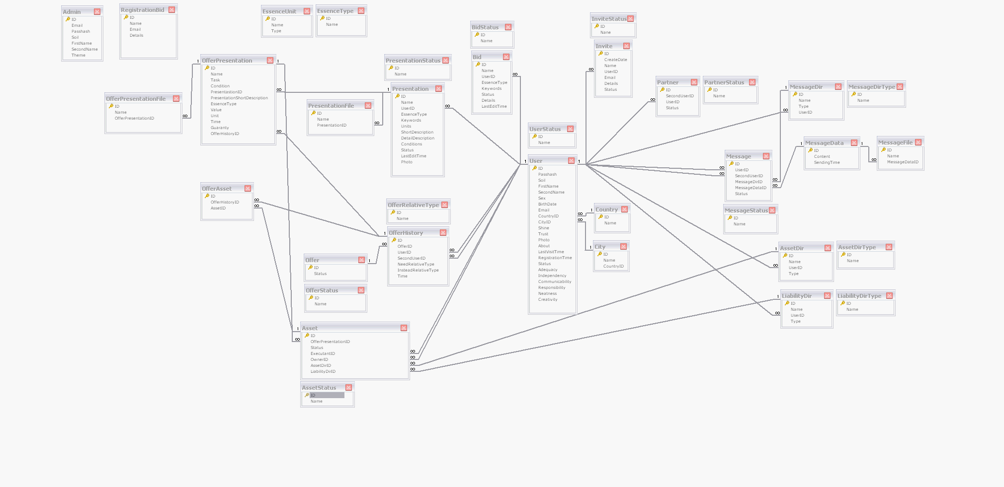
Currently the scheme is constantly refined and expanded over the new desires of the customer.
In addition, the project uses a functional: the implementation of Payment by ROBOX, sending messages during actions in the system relating to the user the possibility of combining users into interest groups and cooperatives (with the introduction of own resources), search engine sex all the resources the system messages within the network system for creating special invitations to the network by mail or by using a promotional code, the system is privacy - the ability to specify the persons to view the resources (all, none, partners ... (choose from a list), partners in the group), the choice of location with own base of cities and countries, etc.
In June 2011 it was decided to partial changes in the direction of the project to improve the user interface, clarity and usability, so below are pages on which functionality is significantly different from the previous one and which are under development, but will be used later:

- Registration
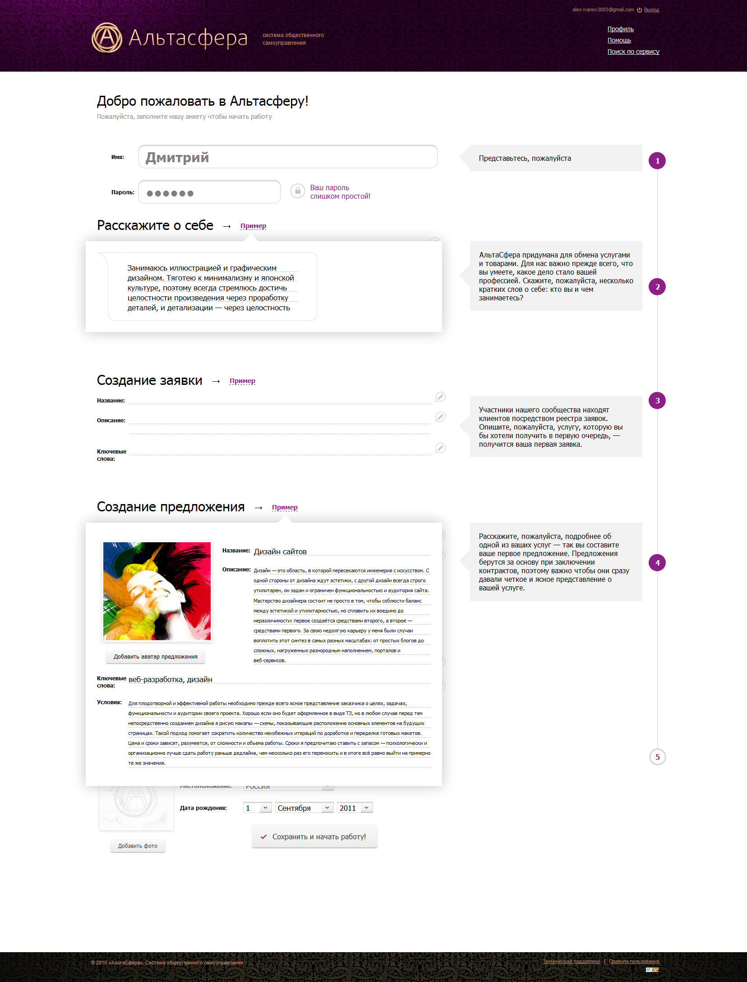
Step-by-registration to the completion of the required fields and pop-up example to fill them.

- Page creation contract
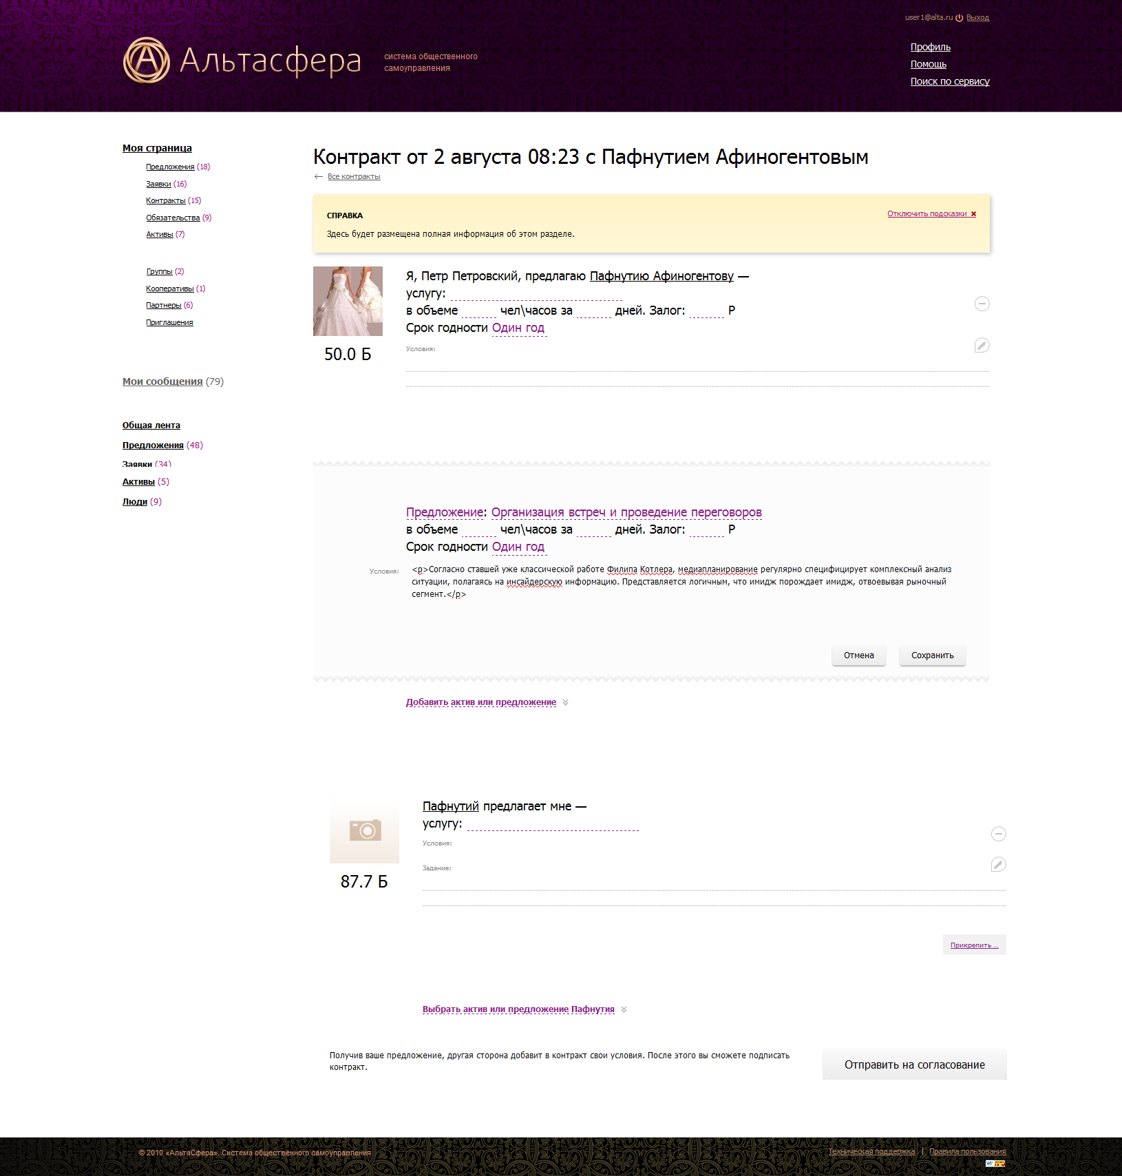
Dynamic creation of a contract with any number of attached resources. Added module tooltip (the text is added to the admin area for different pages.) Added plugin change the name and last name, depending on the type and case.

- Page creation proposal
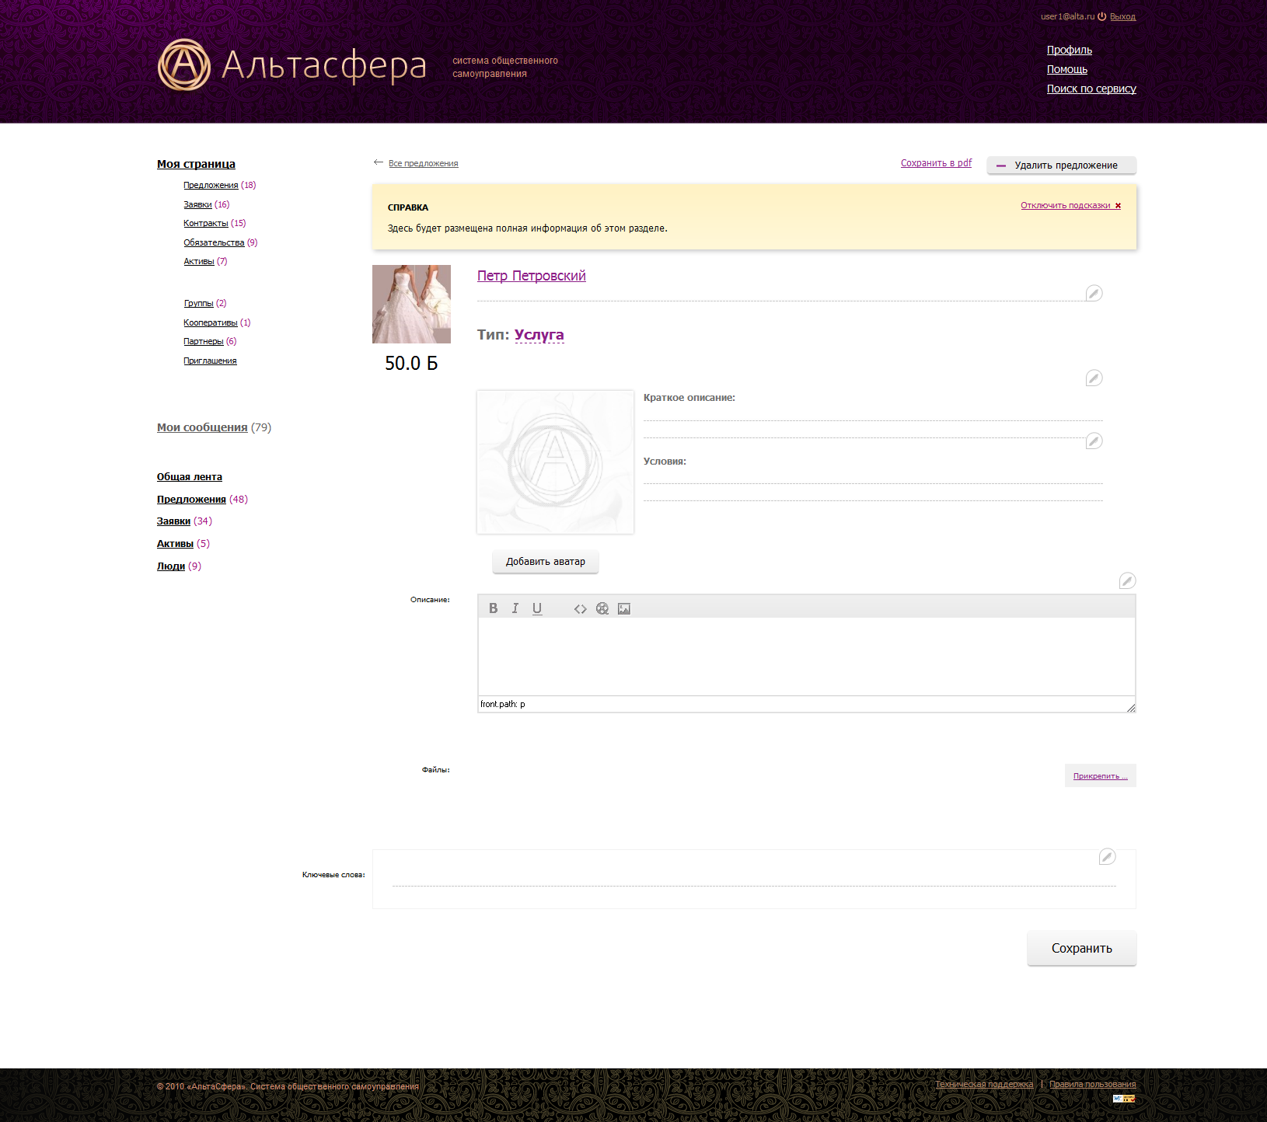
Using a text editor and the possibility of saving the page in pdf-format.

- Page asset
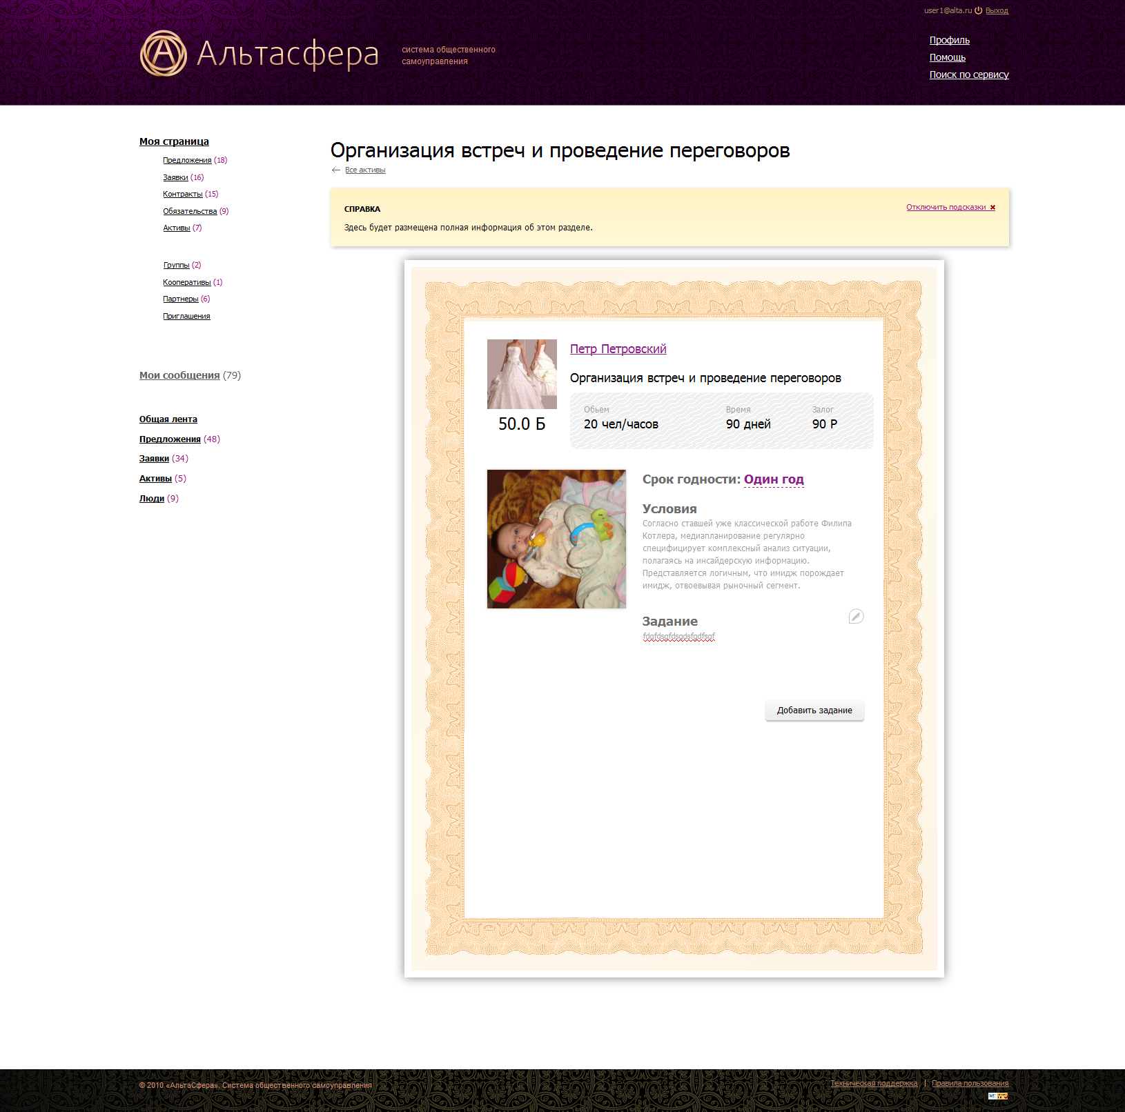
On the page of the asset, depending on the status of an asset may be eight different situations - can be edited field when viewing the holder of the asset may be a variety of buttons and labels. All display made ​​possible only in one template.
Also has been added to the attachment / file mapping, functional and a total tape messages, which can edit text files.
The administrator panel to view the websites of registered users who view the proposals and their approval, change the password for the user viewing messages, arbitration, additional features to add text to the modules' Tip of the Day "and" Help. " For the convenience of the administrator the opportunity to choose a color scheme admin.
  - Choosing a theme for the administrator profile
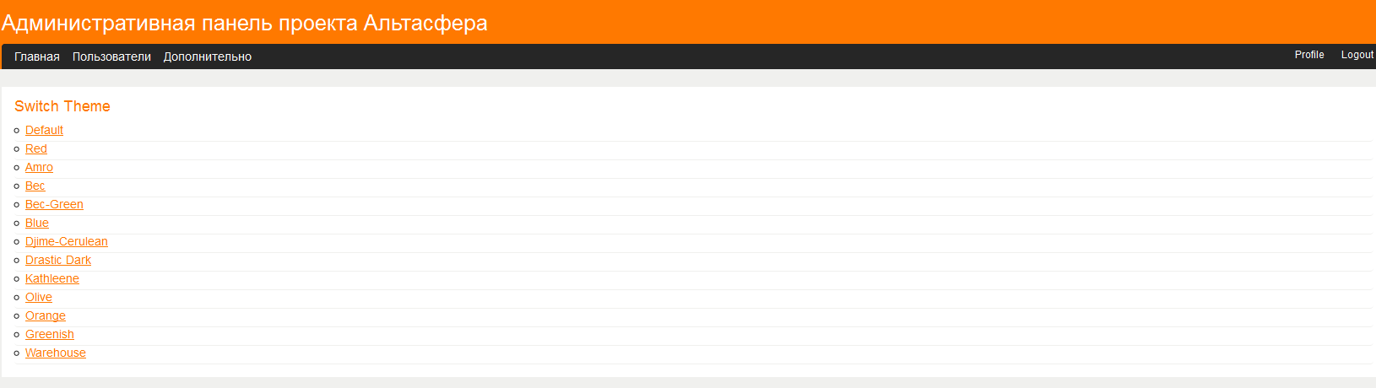
  - View a list of users
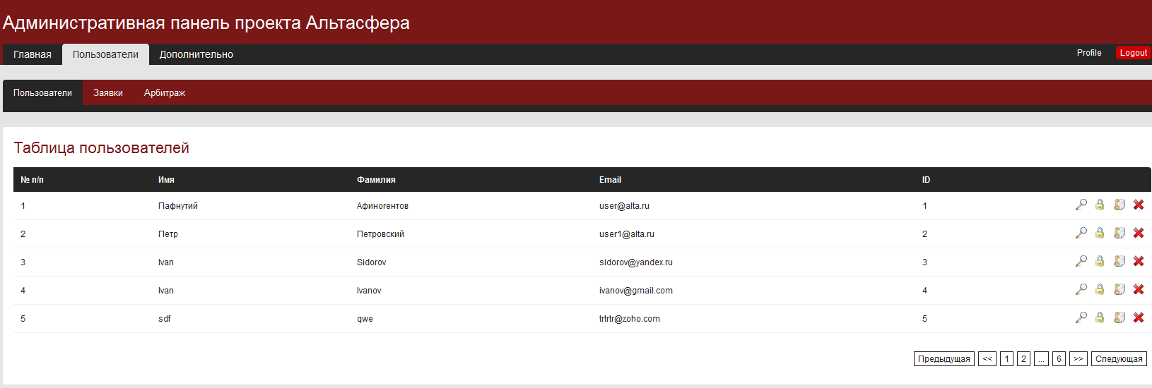
  - Create / Edit board
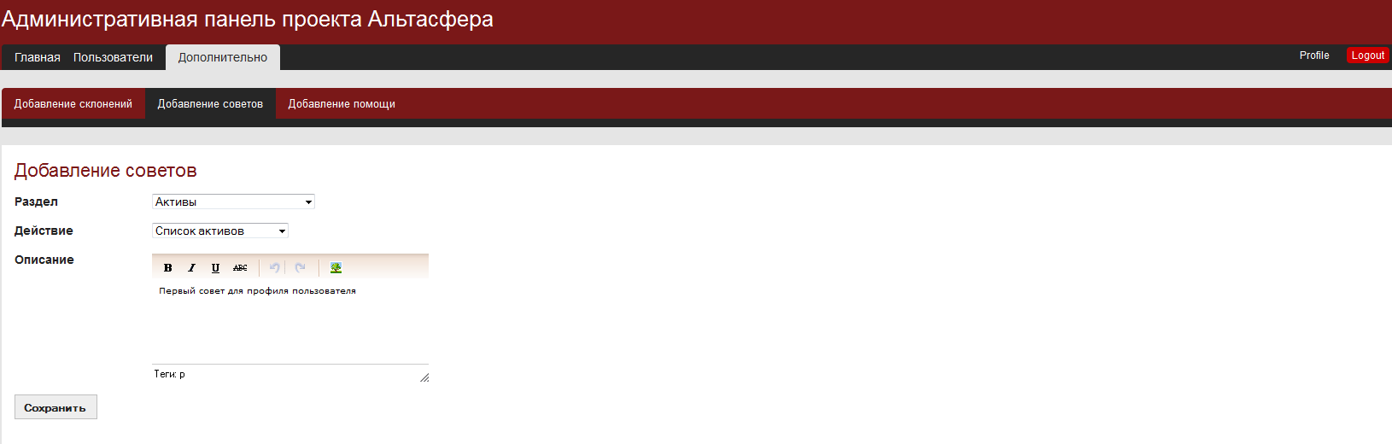
Use a text editor for text. For the convenience of the administrator create a table of all the pages on the principle of partition / action. When you select a partition action is chosen only from this section.

