Project Description "Glossary"
System Description
The project "Glossary" has been developed in order to allow preparation of multilingual glossaries of terms used in technical documentation for major corporate projects, which require compliance with unity terminology.
The system is a multi-user web-based application database.
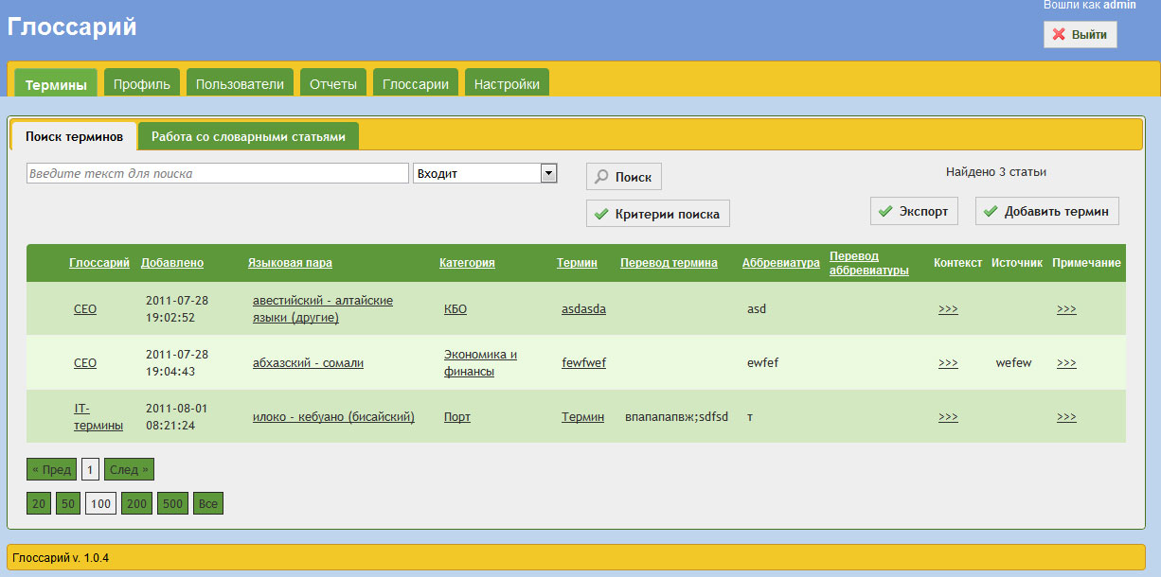
Home Application (view vocabulary units)
System groups (roles) and the sources of their rights. User roles
The system concept of "role" is used in three ways
1. System-wide roles (roles within the system as a whole)
2. "Indicative" role ("indicators" that are "sticking" to the Administrator for the convenience of users of their choice for the role in the glossary)
3. Role in the glossary (real roles that define access rights to the lexical unit in the glossary)
System-wide roles:
1. Administrator
2. User
3. Anonym
The administrator has their own rights (such as creating users, glossaries, etc.), as well as the rights of all other roles.
Example: An administrator can open the glossary, and using a moderator, to connect to the glossary editor.
The administrator can edit the personal user field in his profile.
Members come from the right:
1. Their roles in separate glossaries
2. Their relationships with individual lexical units:
a. Author lexical units
b. Responsible Editor entry unit
c. Approved the Advance editor who approved the lexical unit
Anonymous - a user to logon or user who was logged on their own, but has not yet received approval of its
Registration Administrator. Anonymous can only view the registration page and carry out registration.
Role in the glossary
1. Moderator
2. Advance Editor
3. Editor
4. Translator
5. Reader
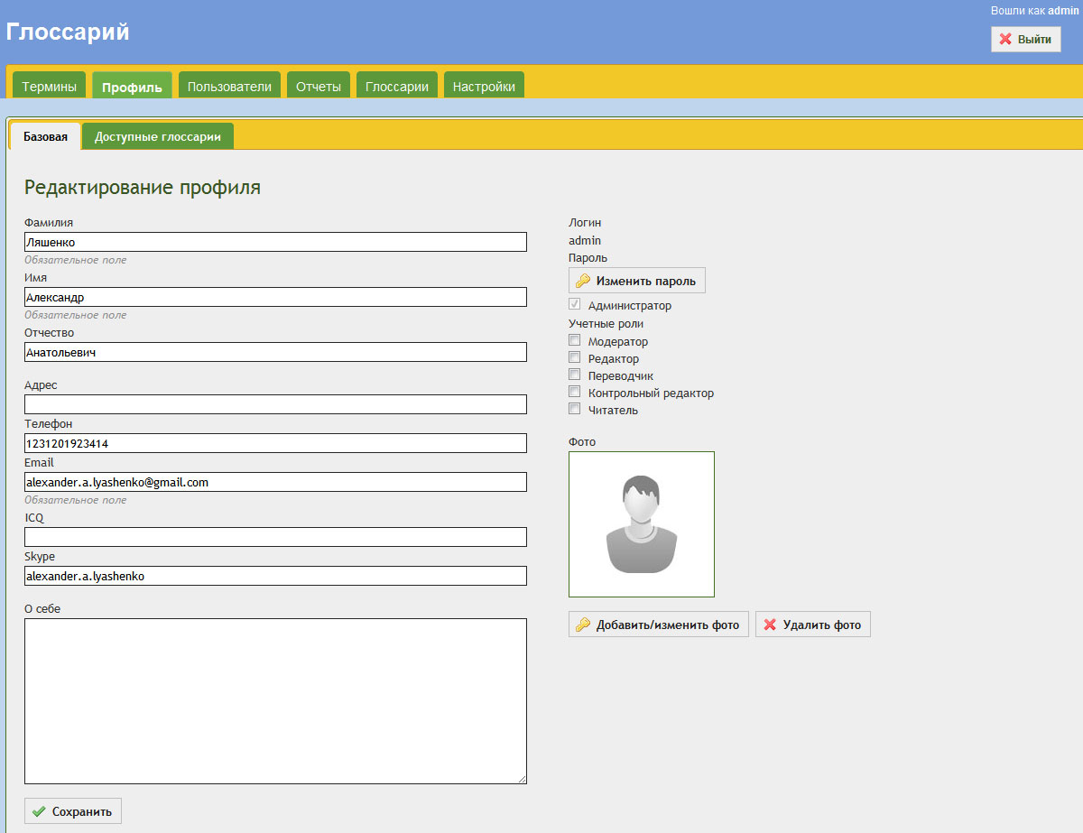
User profile page (the administrator can change user roles indicative)
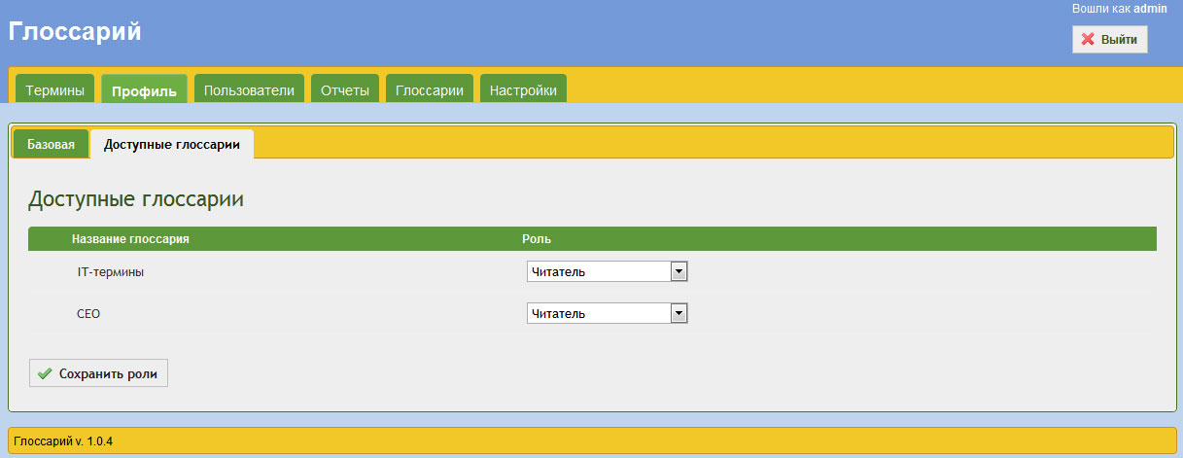
Glossary available to the user and his role in them
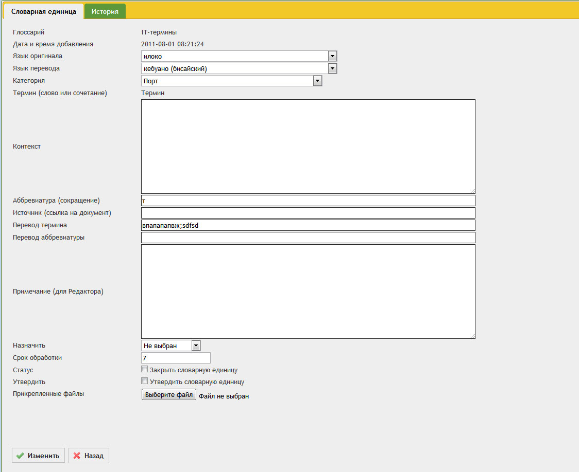
Page to create a new vocabulary items (changes in set up)
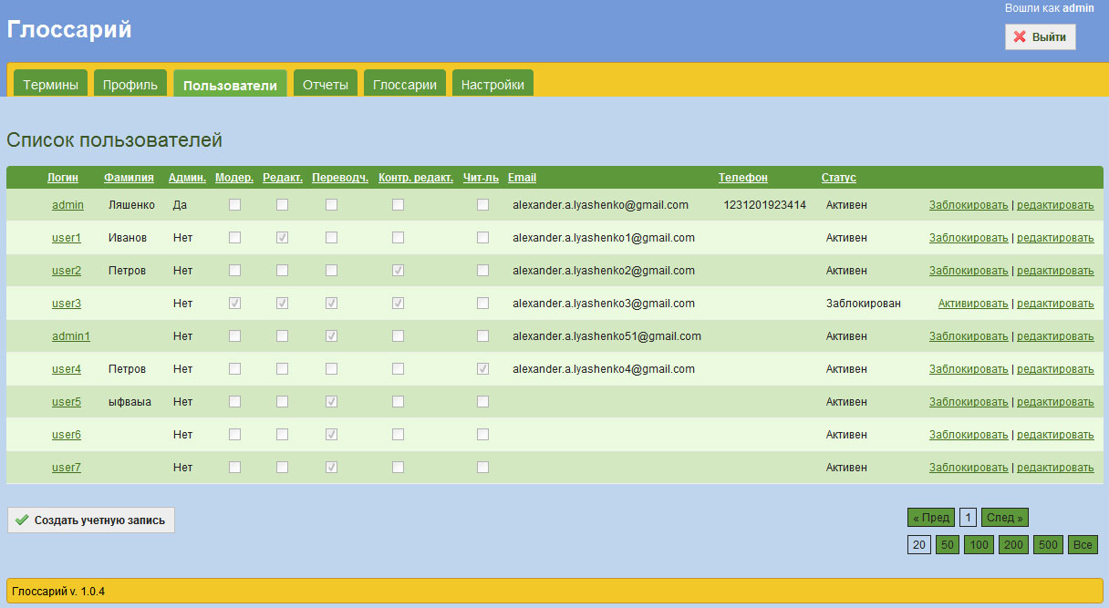

List of users of the project (only available to)
The application allows users to view reports on a new, open, closed lexical units, graphics for statistics.
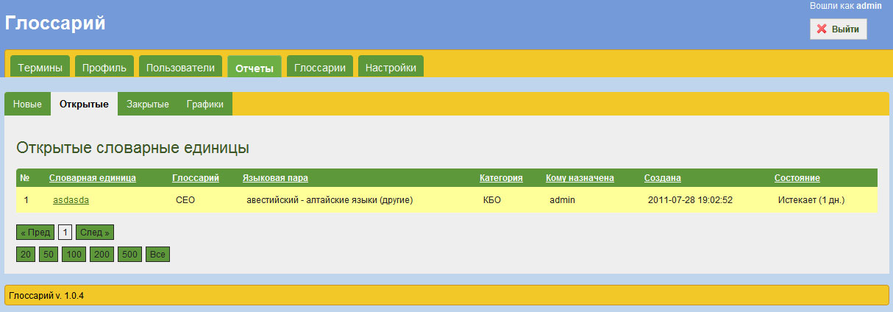
Page reports
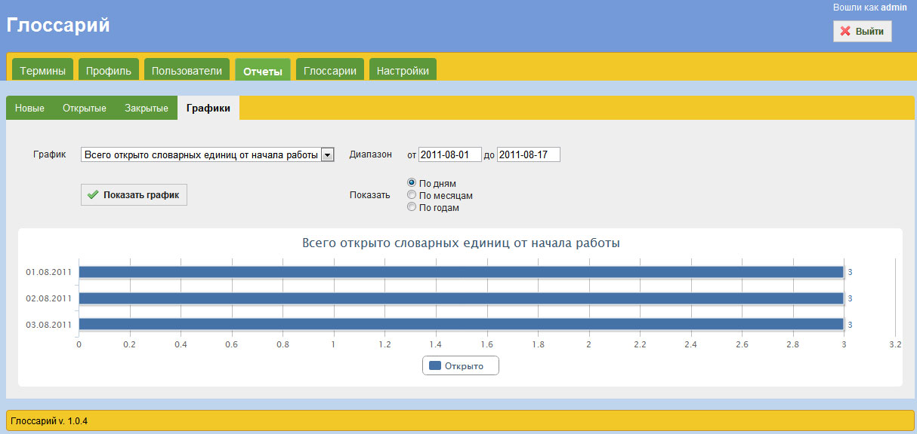
Page graphics
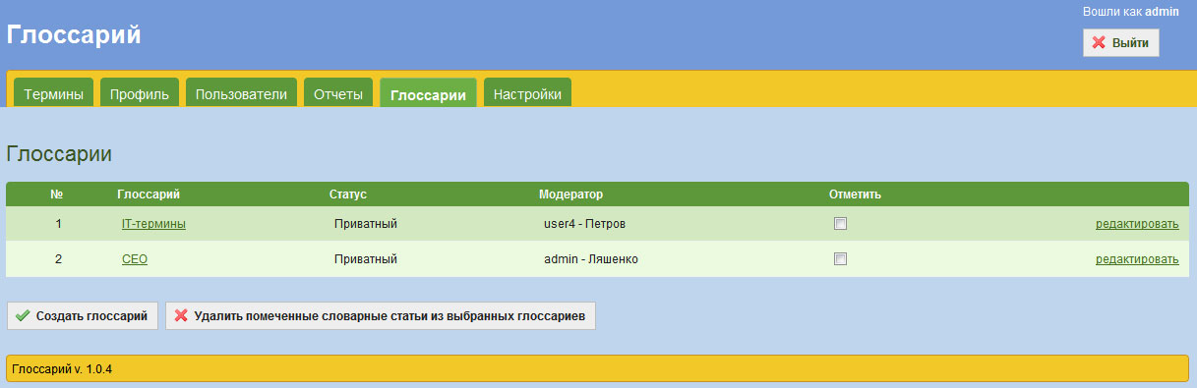
Glossary page (see the administrator)
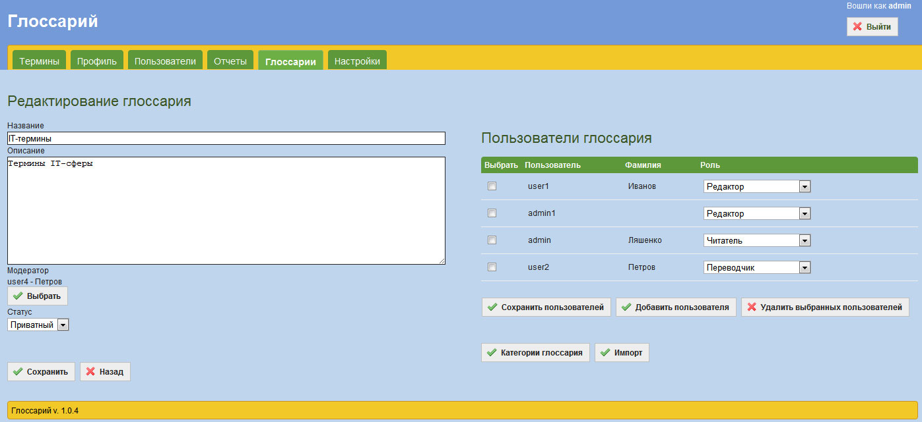
Page creation / editing a glossary
Administrator can export a selected vocabulary items in a file format. Csv, and import the vocabulary items in the glossary of the file or from another glossary.
At the same time by checking the validity of the data file, and you can choose to import the necessary vocabulary items.
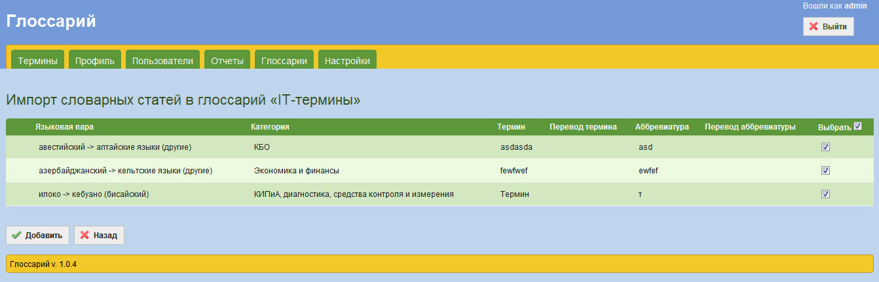
Page import vocabulary units in the glossary
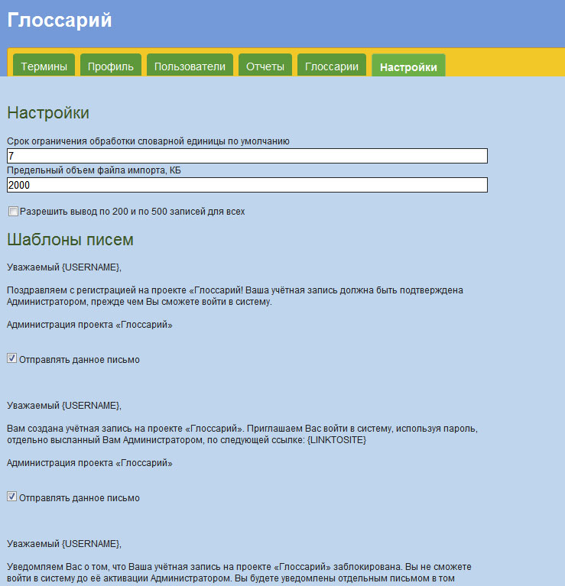
System Settings page (available from the administrator)

