Ile-school
Administrative part (. Info)
The project is remote schools teaching foreign languages, including 2 domain names. Com and. Info has 3 main parts, those parts of the school, itself an external site and admin part website.
Those of a member of:
- What's the general form (weekly), the data loaded by Ajax, every 10 minutes automatically updated. In the project there are several types of roles for each of them set their rights and opportunities. List of roles: the president, manager, technical support, sales, manager, supervisor, coordinator, teacher, student, assistant, recruiter, agent.
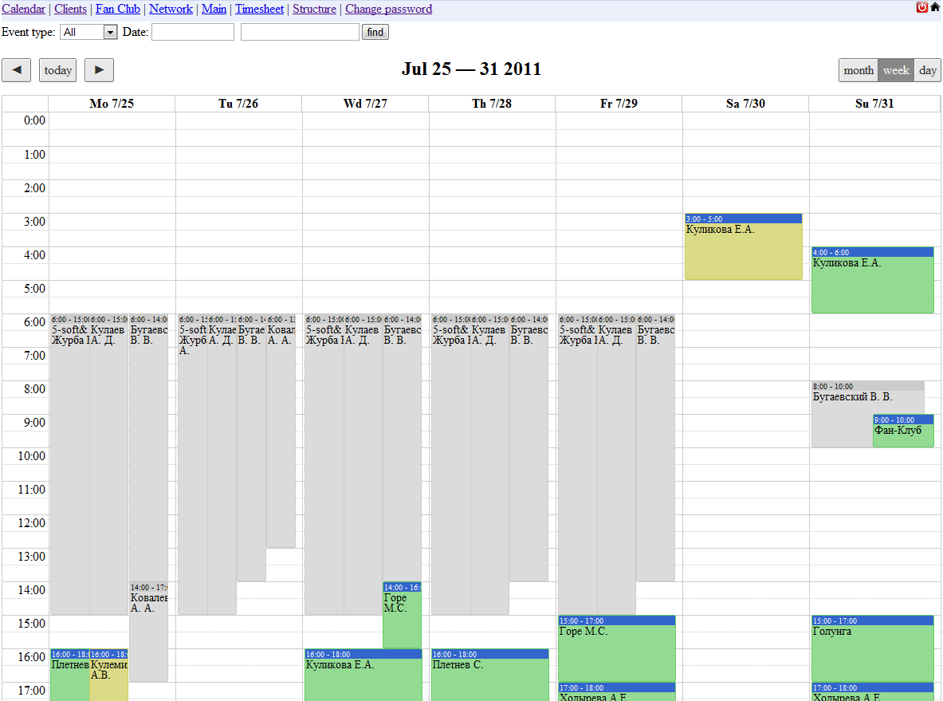
What's the general form of (monthly)
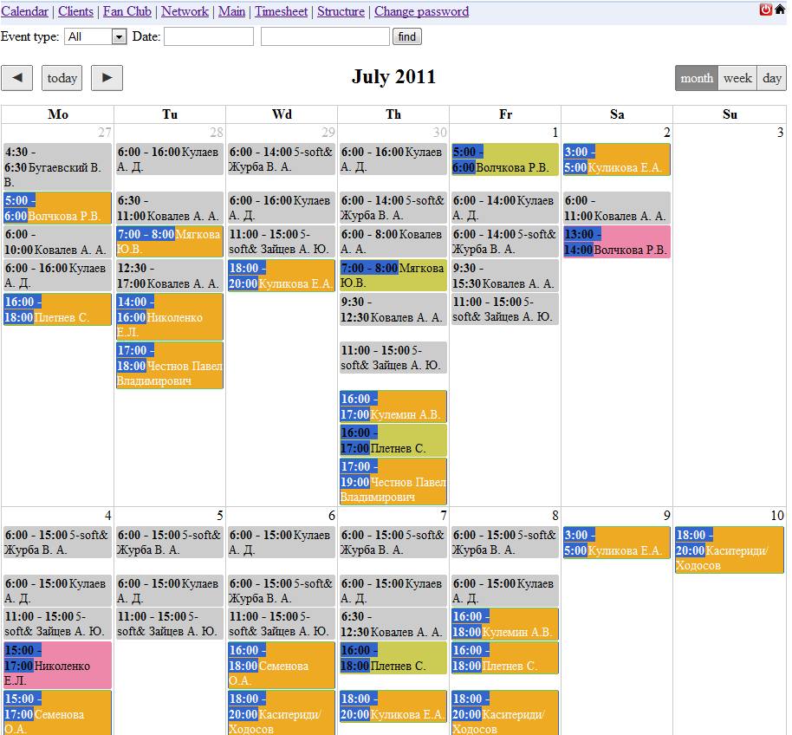
Colors selected group of events (lessons - a blue header, and change - gray)
It is possible to filter events by (all classes, support)
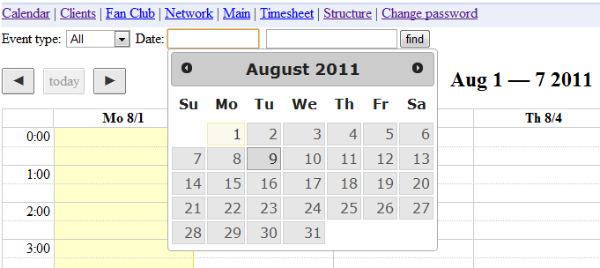
Quick jump to any date
Search the calendar (by the name of the client by the name of the teacher)
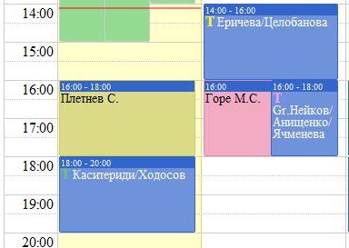
Displays the status of events and responses of teachers conducting lessons of acceptance, the current Greenwich Mean Time
Creating change:
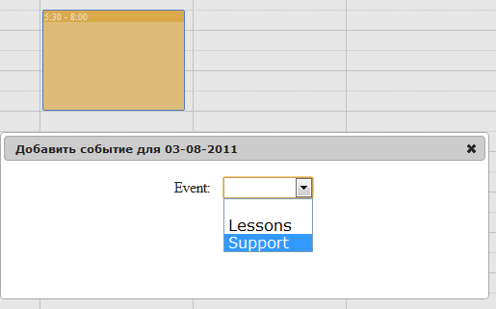
Creating change one day
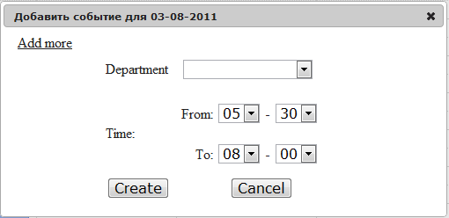
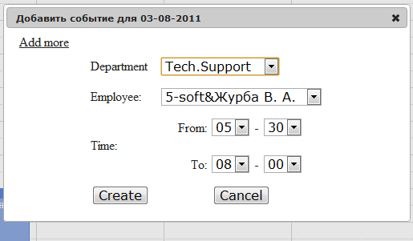
For the week:
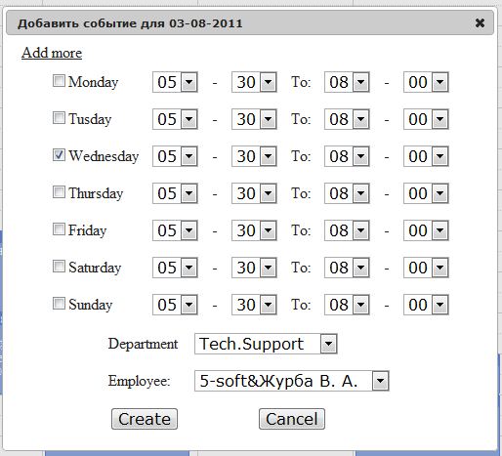
Create a lesson:
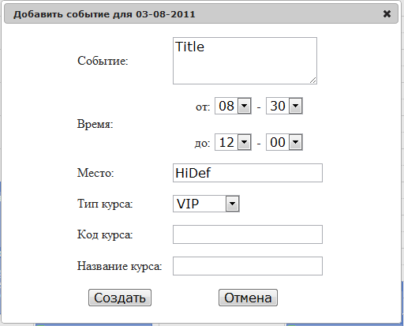
Inside Events
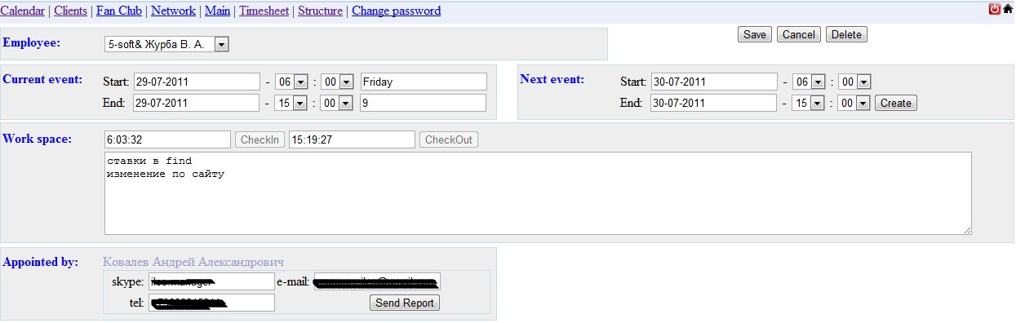
Type Manager (correction and confirmation of the closing time shift)
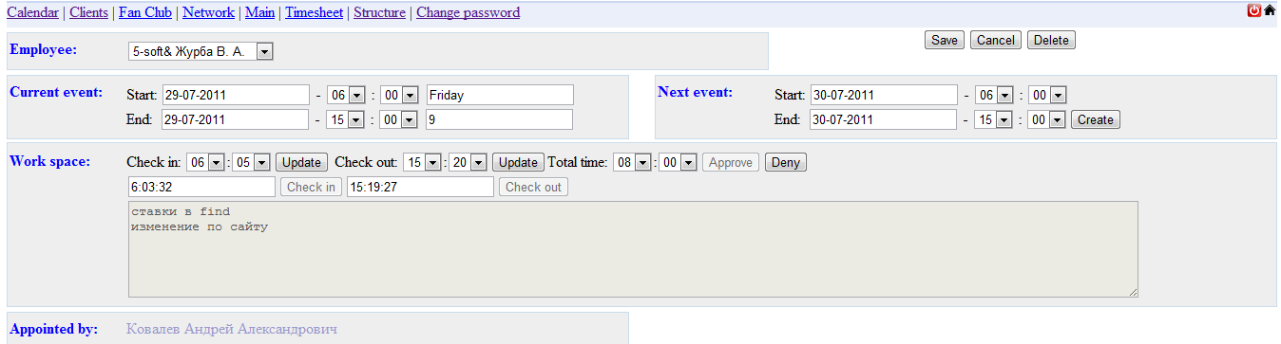
Search by the name of the client
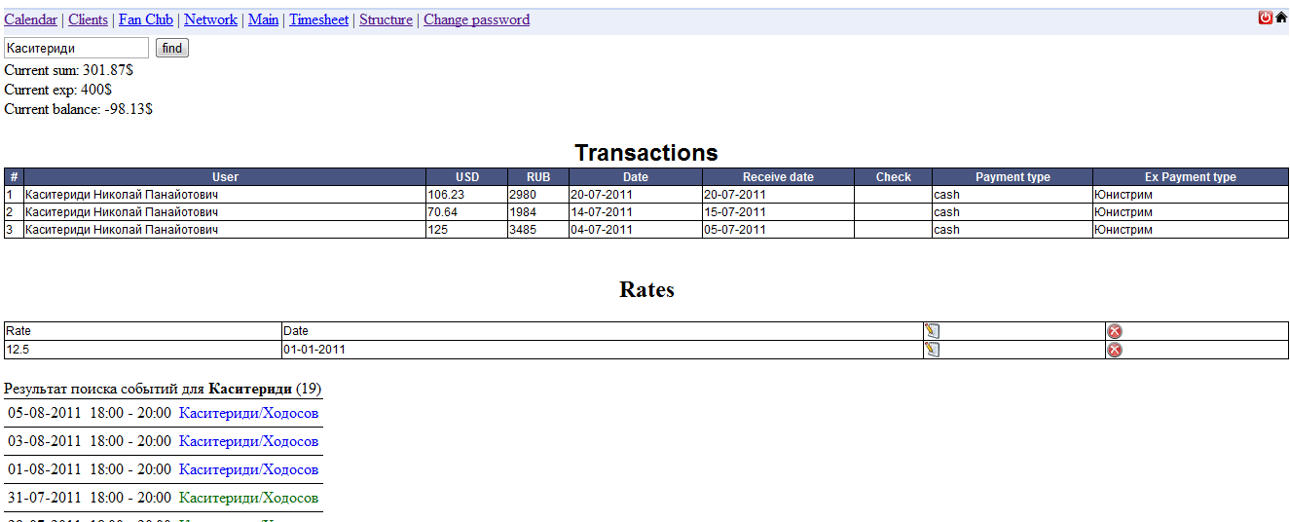
- Customers who provides information about abandoned applications (grouped) website (. Com) ability to apply filters to search for, edit data, add notes, change the group.
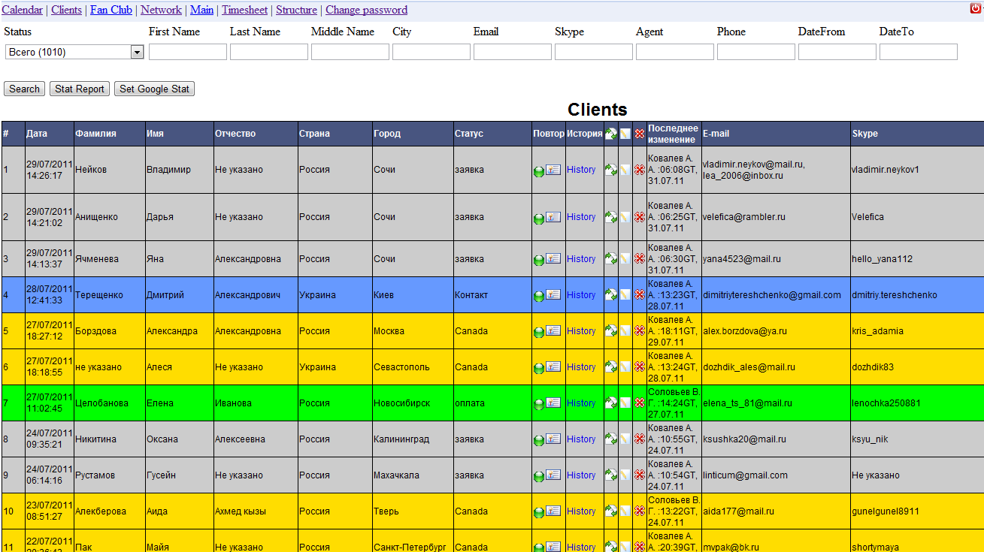
- Section assignments - you can leave someone in person, all or a group task, edit a job or a job that left you. The ability to filter tasks.
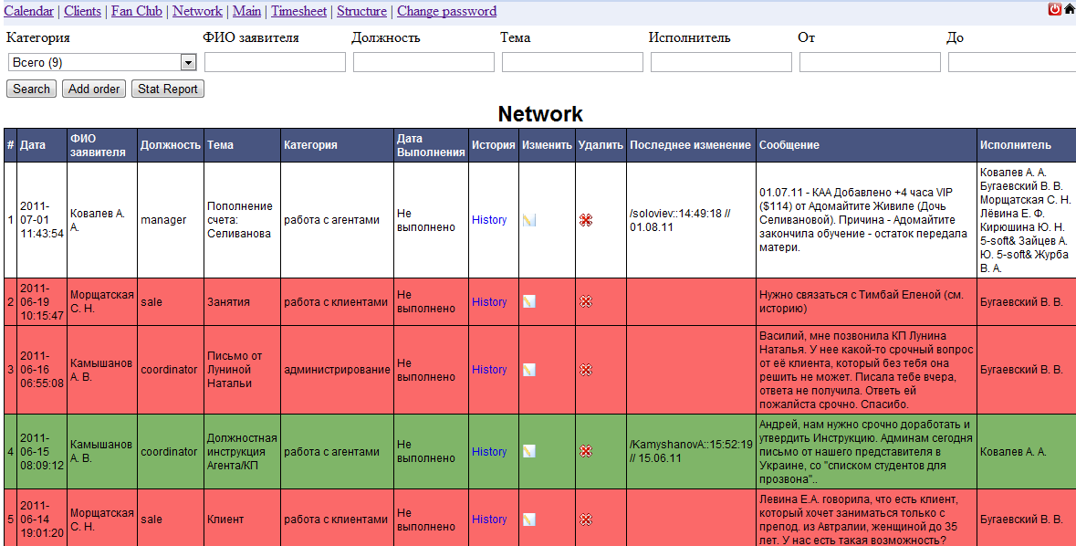
- Category revenue search by user, date, type of payment, change and add transaction
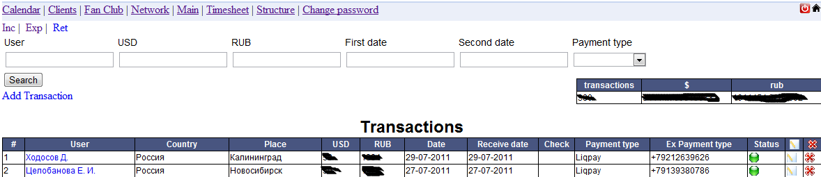
- Section expenditure in the amount of search, department, employee, date, status, change, add, delete.
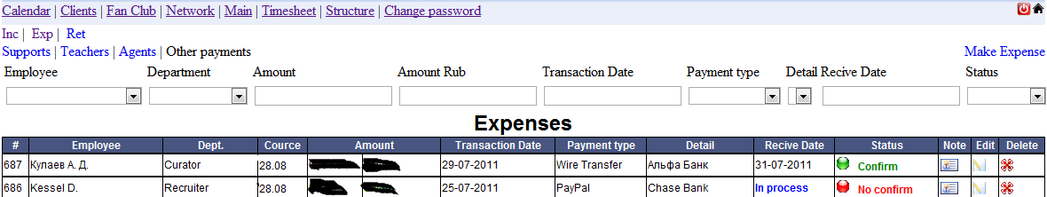
6) Section timesheet - displays the time spent for teachers, assistants and recruiters-weekly, for everyone else - in half a month, also shows a period of paid or not, when you click on the name offers detailed information on the first period, when clicked on a particular part - for this part.
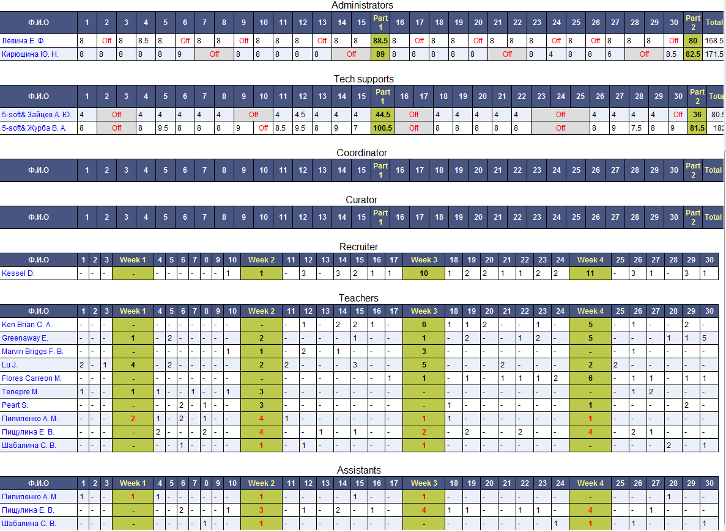
A detailed report on the period (a type of employee)
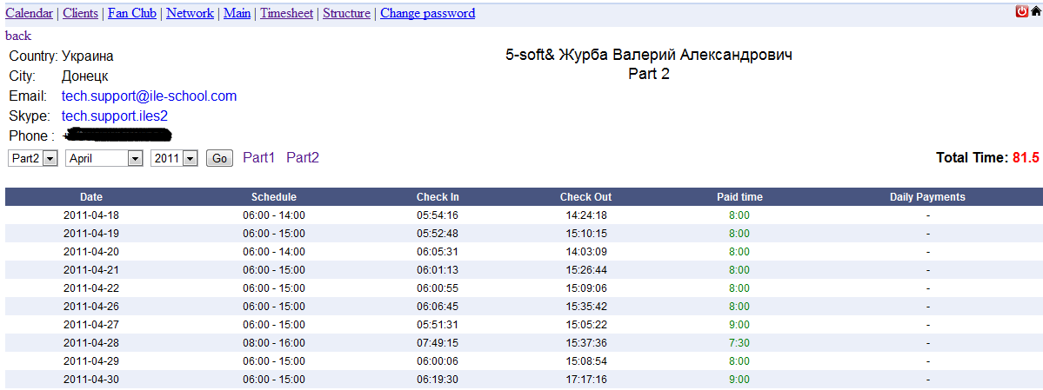
A detailed report on the period (type manager) - The ability to change the hours and rate currency, with the current period for teachers, assistants and recruiters - the minimum interval - a week for the rest - half of the month.
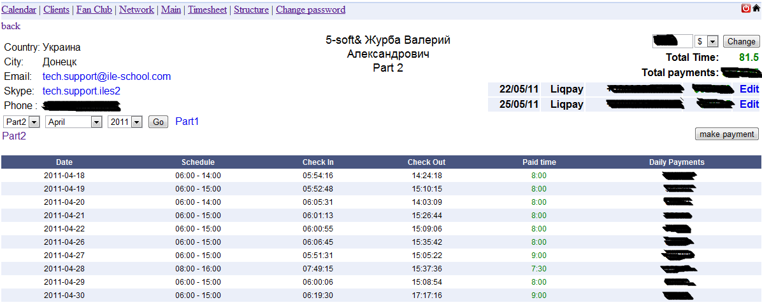
When you click the make payment - automatically replaced in the last billing information officer for the payment amount, the currency of payment. The system automatically calculates the balance, and determine for what period must pass fee, the system can not pay for the current month if not paid for the previous one.
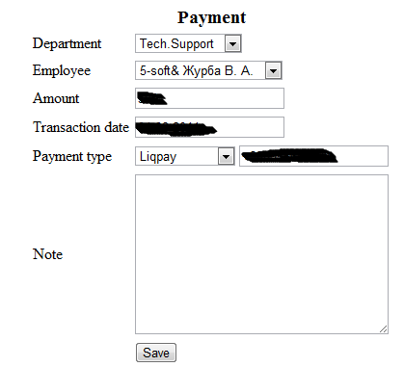
6) The Tree of agents and customers, adding a change of nodes (agents, the interest rate) and users belonging to this site. Sites and users loaded Ajax.
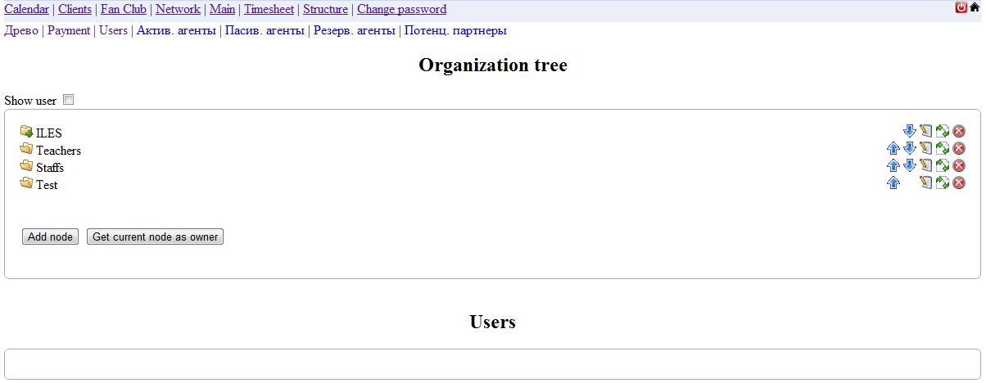
Allows you to add and register users in the current node.
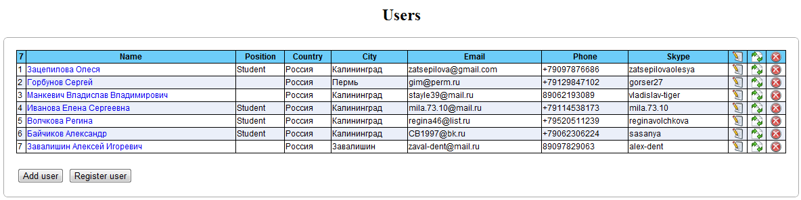
Subdivision of the current state of payments to agents
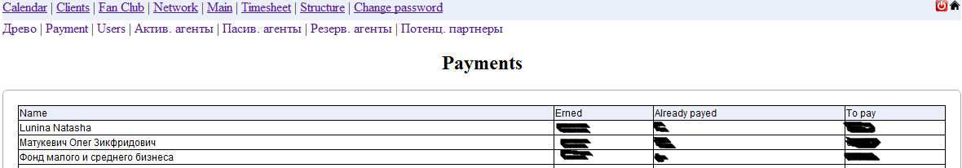
An organizational chart for the accounting site
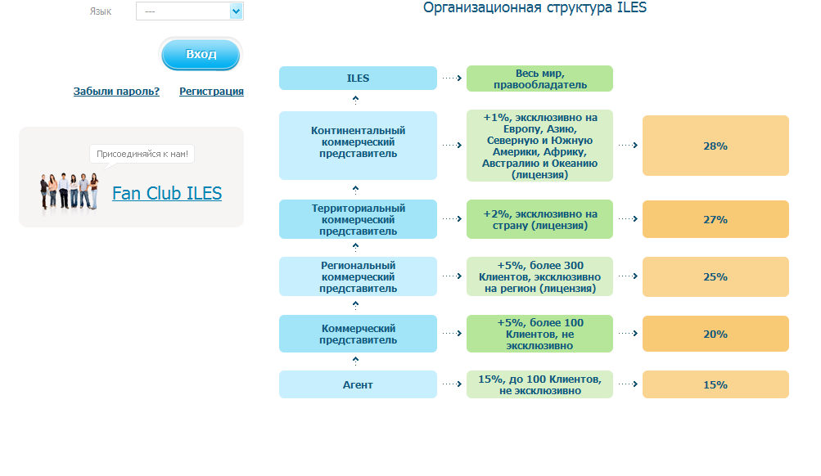
Subdivision allows users to set rates for each user per hour sessions.
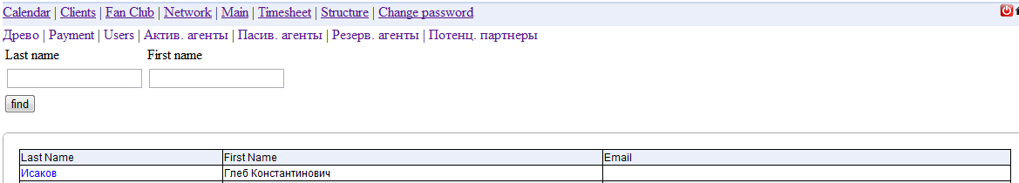
Add a rate change
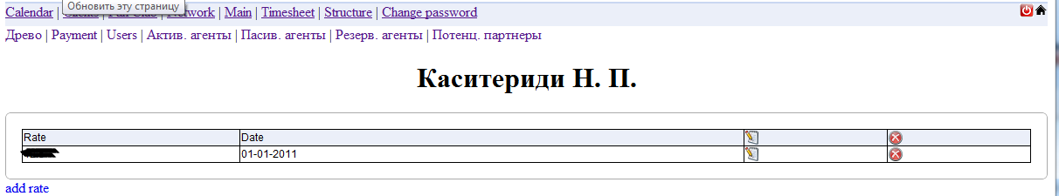
7) My Account user, displays the payment, how much spent, how much is left, the table of payments, interest rates table, the table class. Going into the session user can download the recording sessions. Record is available for 30 days after the class.
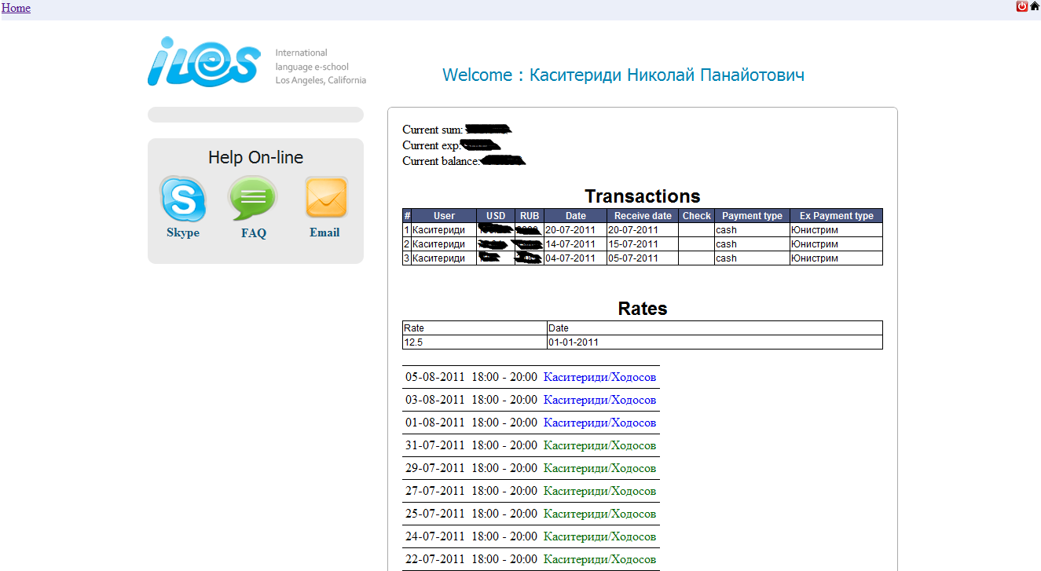
Administrative part (. Com)
Allows you to add pages, sections, edit multi-lingual version of the site, adding the city on the map, edit the list of courses and their properties, durability, price, description.
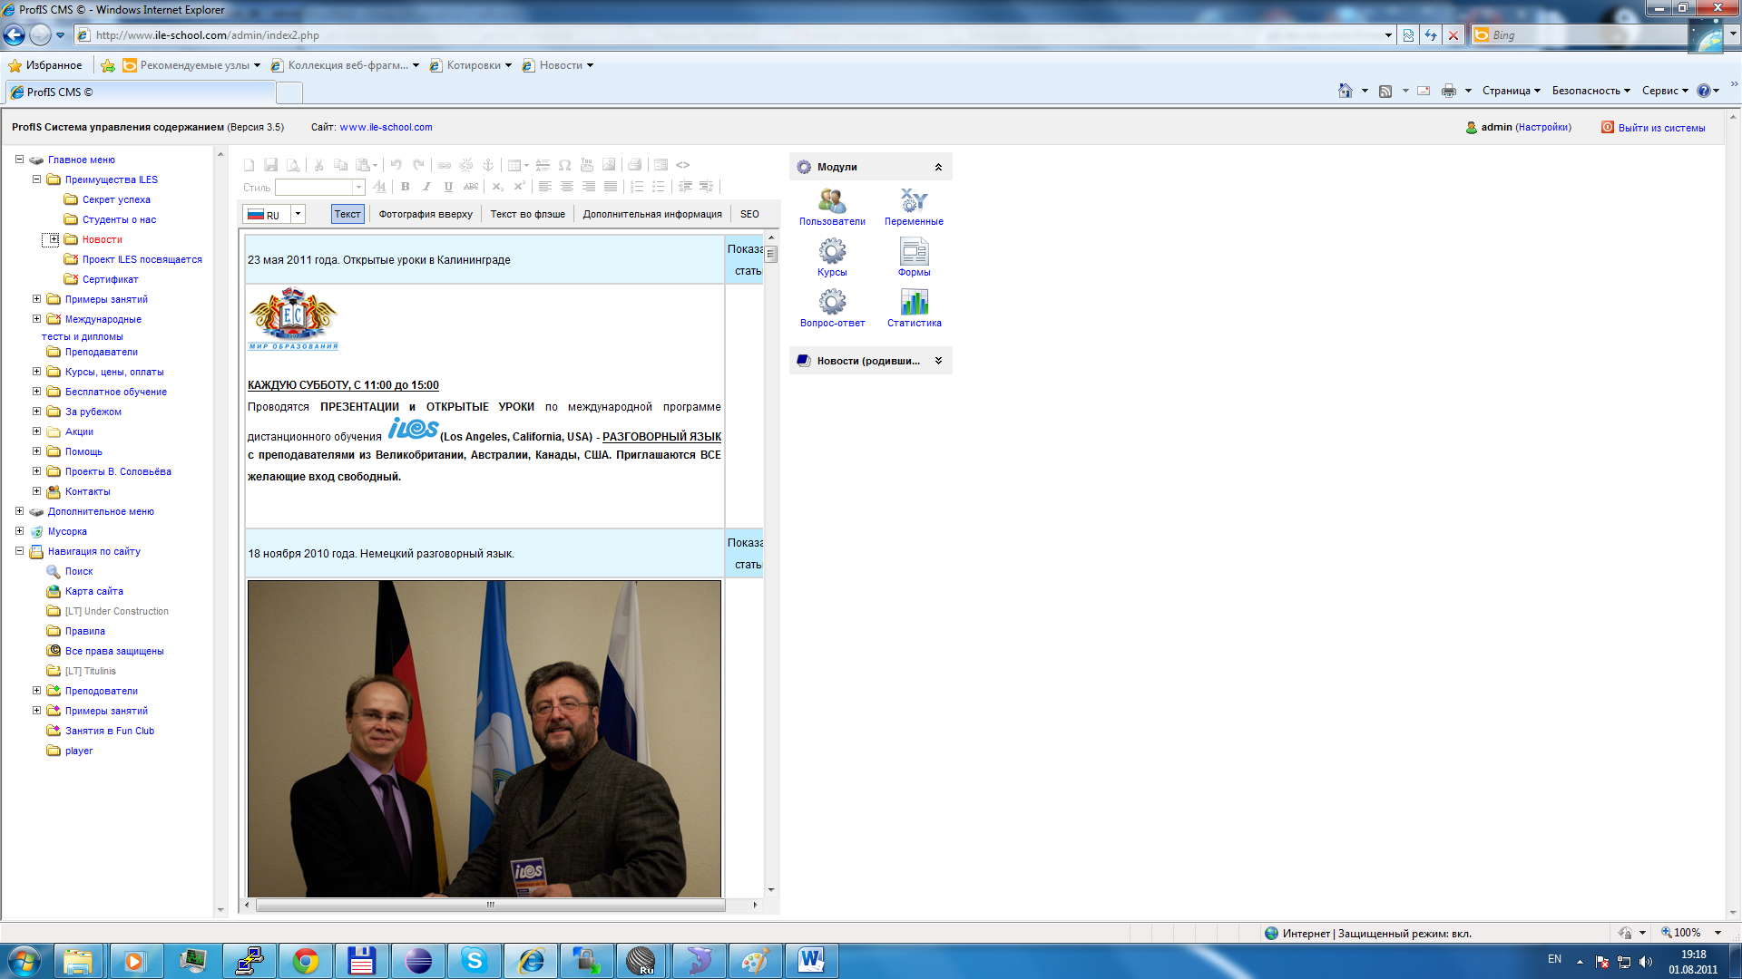
Alter the site structure
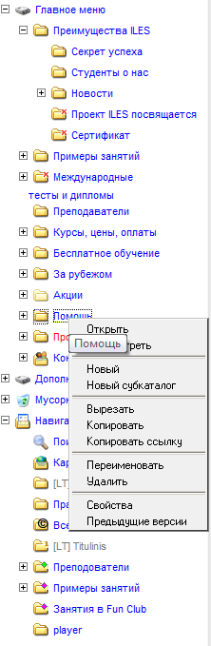

Site

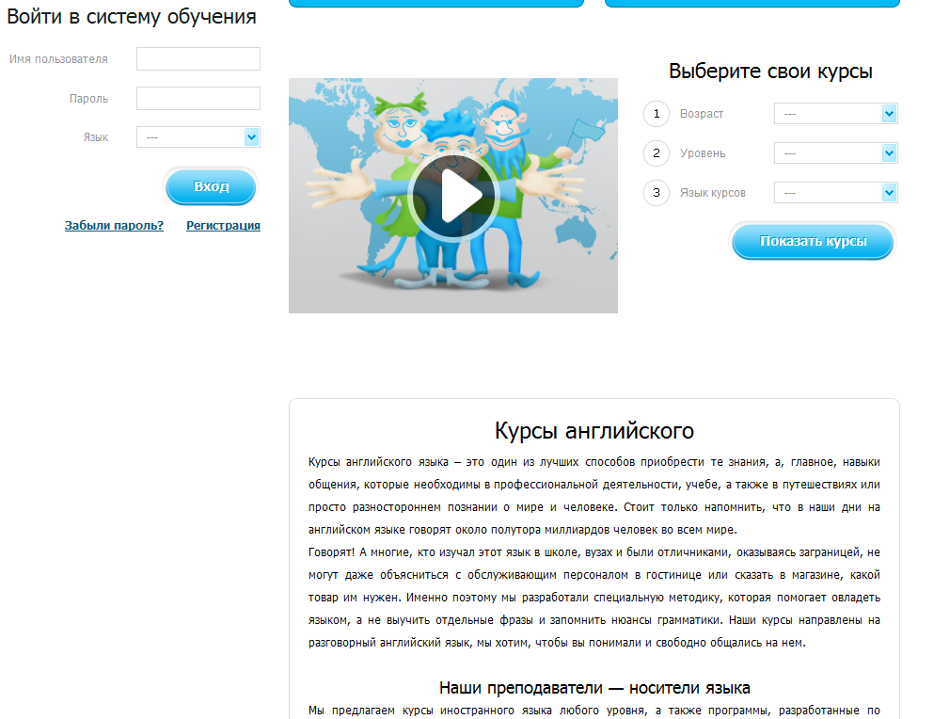
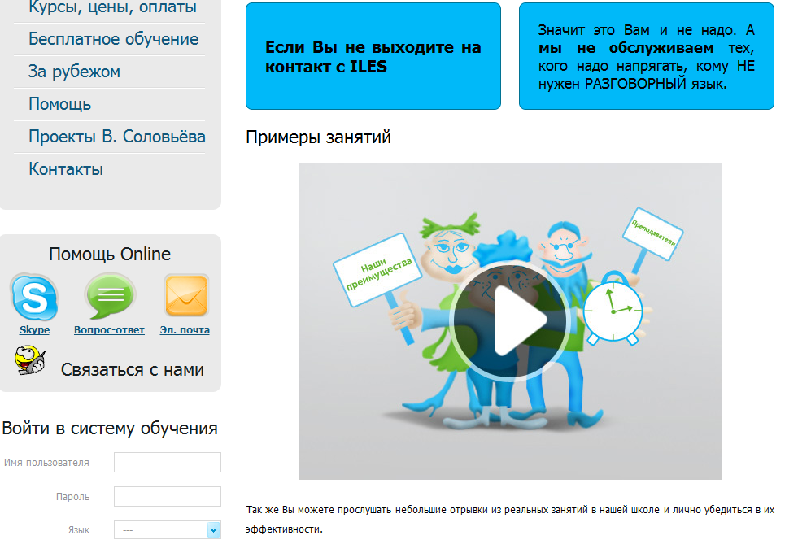
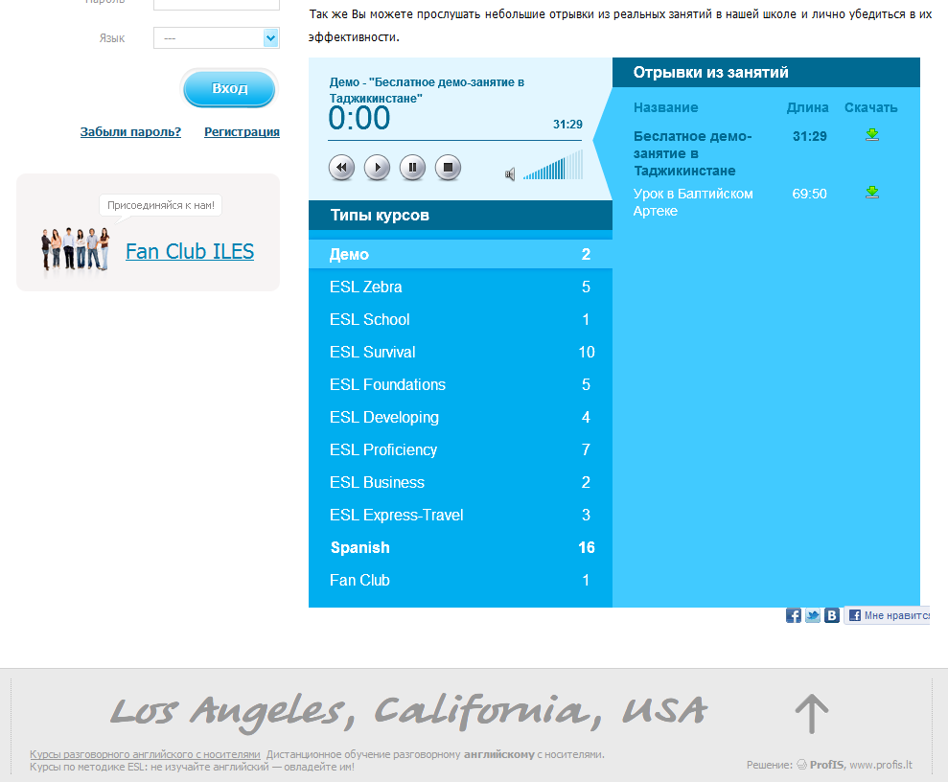
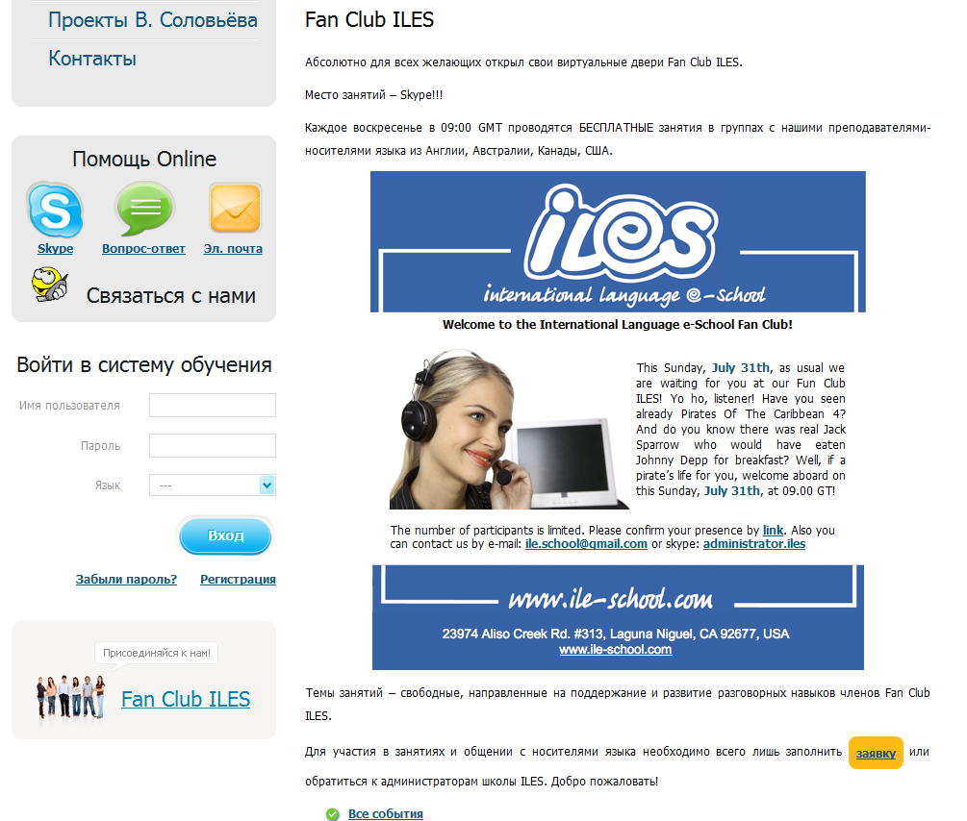
The form for the abandonment of the application
