Application "Suppliers"
Contents
0. The main idea………………………………………………………………………………….3
1. UI to guests………………………………………………………………………………….. 3
1.1. Search………………………………………………………………………………………..4
Screen page "Search for the nearest supplier"…………………………………... 4
1.2. Catalogue…………………………………………………………………………………… 4
Screen page "Search for the nearest supplier"…………………………………... 4
2. UI for customers ………………………………………………………………………………5
2.1 Managing applications………………………………………………………………………. 5
Screen "applications list" for the customers: …………………………………….5
Screen "Create / Edit Application" for the customers:………………………….. 5
Screen "control proposals received on the application"…………………………..6
2.2 Personal notes and correspondence …………………………………………………………7
Screen "Private Messages": ……………………………………………………..7
Screen "Correspondence with the user" …………………………………………7
2.3. Custumer Options ……………………………………………………………………………...8
2.3.1. Company Profile…………………………………………………………………. 8
2.3.2. Personal settings ………………………………………………………………….8
2.3.3. Notice to the Custumer …………………………………………………………….9
2.4. Human Resource Management…………………………………………………………….. 10
3. UI for suppliers………………………………………………………………………………..10
3.1. Order Management …………………………………………………………………………10
3.1.1. Management of orders to suppliers ………………………………………………10
3.2 Private Messages ……………………………………………………………………12
3.3. Provider settings ……………………………………………………………………12
3.3.1. Company Profile Supplier ………………………………………………..12
3.3.2. Location of warehouses …………………………………………………..13
3.3.3. Personal settings ………………………………………………………….14
3.3.4. Interests of the Company …………………………………………………14
3.3.5. Notification settings ………………………………………………………14
3.3.6. Staff ………………………………………………………………………………14
4 UI for administrator …………………………………………………………………………...15
4.1. Management of goods ………………………………………………………………15
4.2. Managing custom fields …………………………………………………………….15
4.3. Moderation reviews and appeals …………………………………………………...19
4.4. Setting up the calculation ratings……………………………………………………20
5 What is common to all registered users……………………………………………………… 21

0. The main idea
The main idea of the application - the creation of applications for products that can have arbitrary characteristics, and the subsequent notification of new applications received by the suppliers to whom the application fit (they can supply them). Suitable criterion is based on the application settings provider interests - namely, the regions of interest and demand for goods.
The application includes the following roles: guest, administrator, customer, supplier.
1. UI for guests
The screen is the main page of the application:
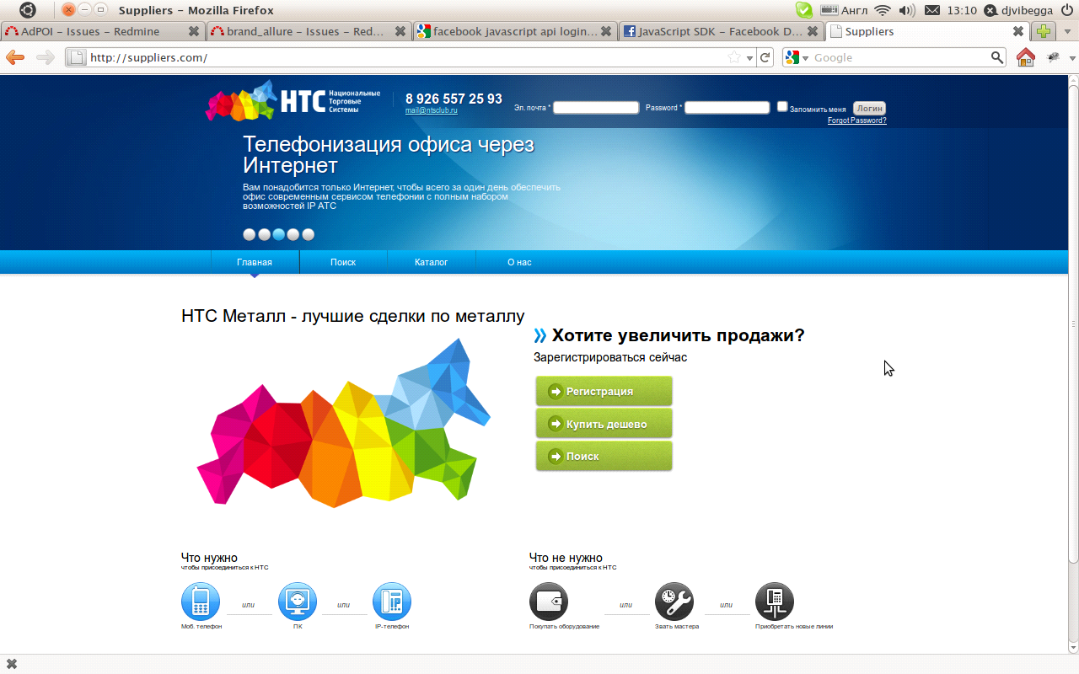
Functional for the guests includes the following topics:
- Search
- Directory

1.1. Search
Screen page "Search for the nearest supplier":
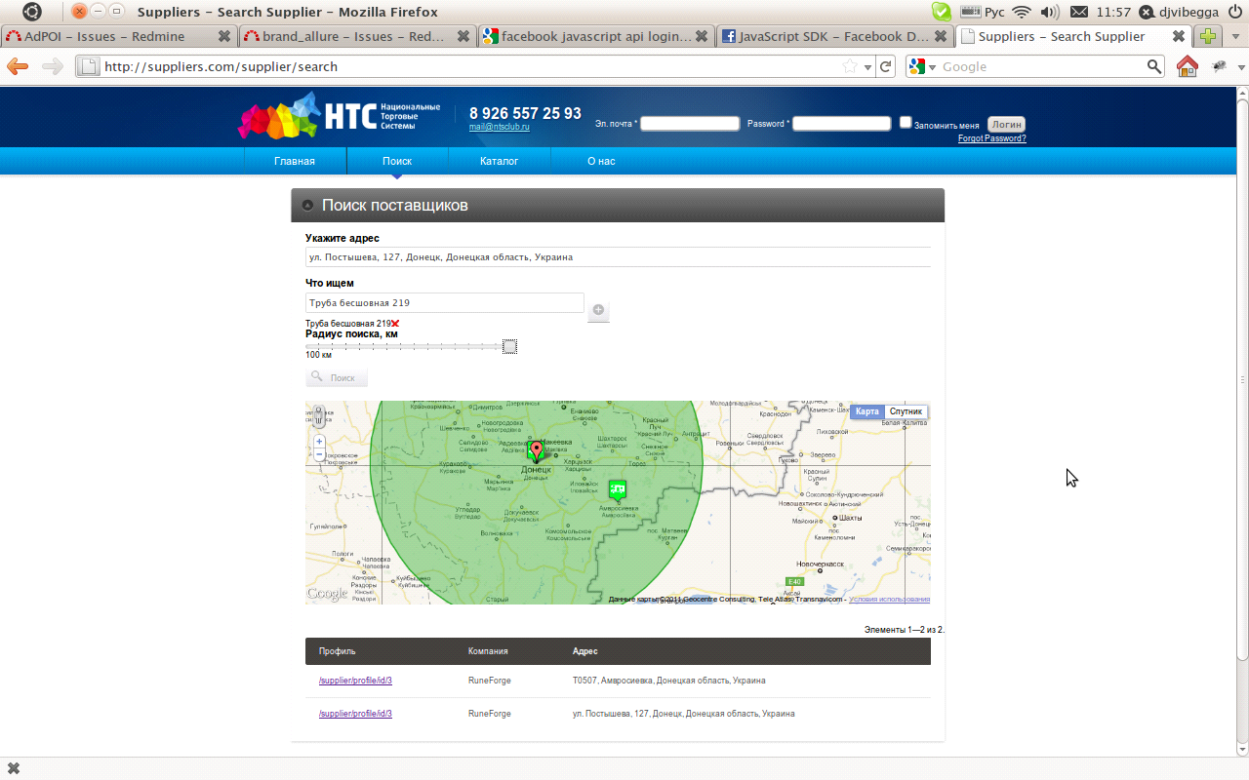
On this page the user selects the address (searching through Google Maps API), goods that he wants to deliver himself (look at our database - a tree-like structure, about 30000 entries). Next, select the search radius in miles. The system produces results at the same time on the map as markers and in the results table, which has links to the profile page of suppliers.
1.2. Directory
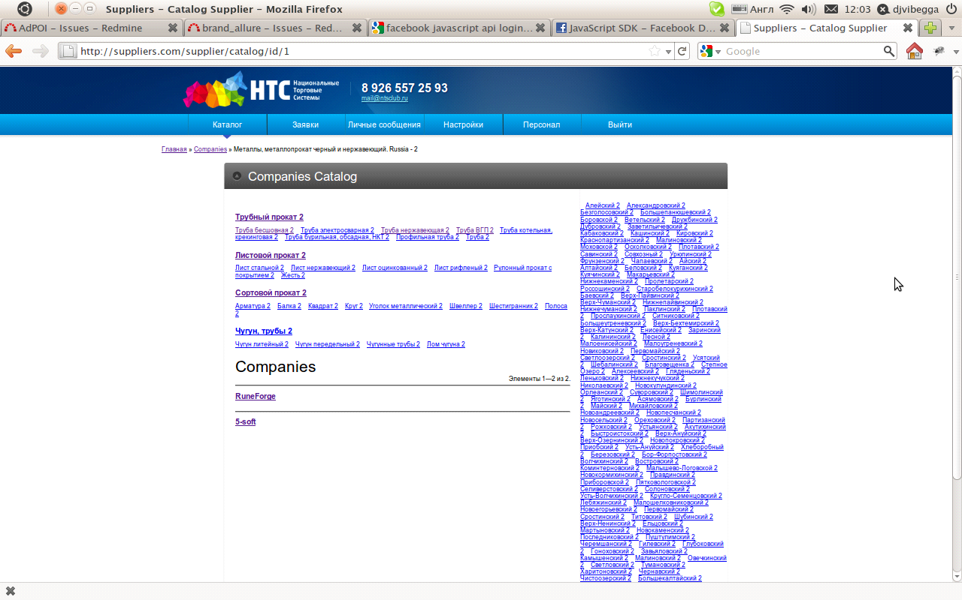

On this page you can browse (search) of providers, category, and the city (approximately 20,000 records). From the top - by the goods to the right - by the city.
2. UI for customers
Customers can be of two types: physical and legal persons. Legal persons have staff who can fill the section UI «Staff." Accordingly, in the Custumer's account are two podroli - "Custumer-manager" and "customer-employee." For the "Custumer-administrator" access all features akkaunnta "Custumer", and for the "Custumer-employee" only - management applications and edit the personal information about yourself.
The list of options available to "Custumer":
- View directory of suppliers.
- Find the nearest supplier.
- Management applications.
- Personal communication.
- Settings.
- Staff.
2.1 Managing applications
Screen "applications list" for the customer:
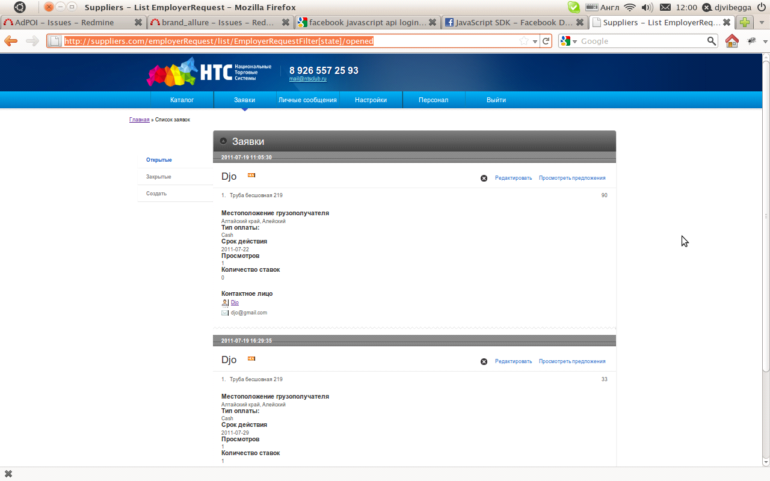

On this page the "Custumer" sees a list of applications created by them and can filter them by status (open hole).
Screen "Create / Edit Application" for the Custumer:
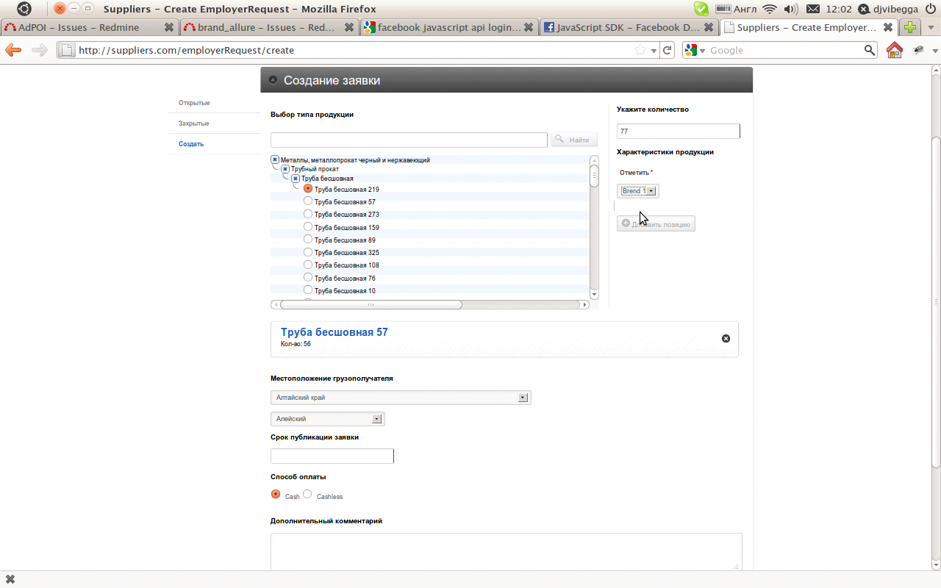
The Custumer can create a new application or edit previously created. In compiling the application, the user can add a product in order at the same indicating the required number of copies, as well as the necessary characteristics of the selected type of goods. Select your region to deliver the (city), an expiration date of the application and method of payment (cash or bank transfer.)
Note: The specifications for each type of commodity can be its own and can customize their system administrator. Moreover, in addition to setting these fields the administrator can edit the template form to fill out these characteristics.
Screen "control proposals received on the application"
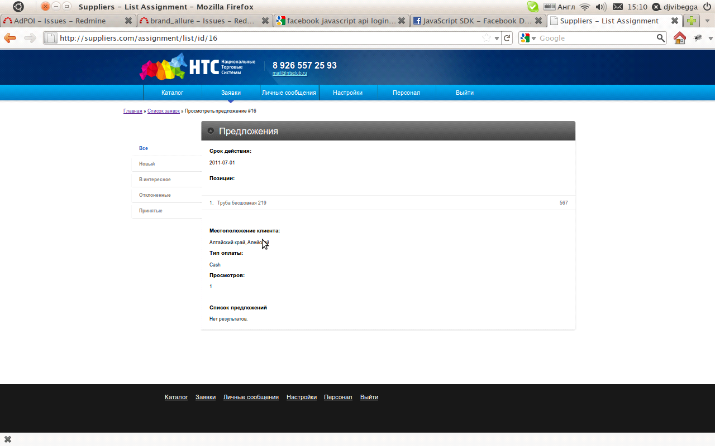
On this page you can view the proposals received for delivery of goods (price + comment), and has the right to refuse or consent to the supply of goods for a particular proposal. Besides the fact that changes are visible in the system, the system also notifies each vendor and the Custumer of any changes that have occurred with the application form by email.
2.2 Personal notes and correspondence
Screen "Private Messages":
This page displays a list of correspondences with other users of the system (number of new incoming messages, and brief information about users that was conducted correspondence). Clicking on the name or avatar, we go to a page of correspondence:
Screen "Correspondence with the user"
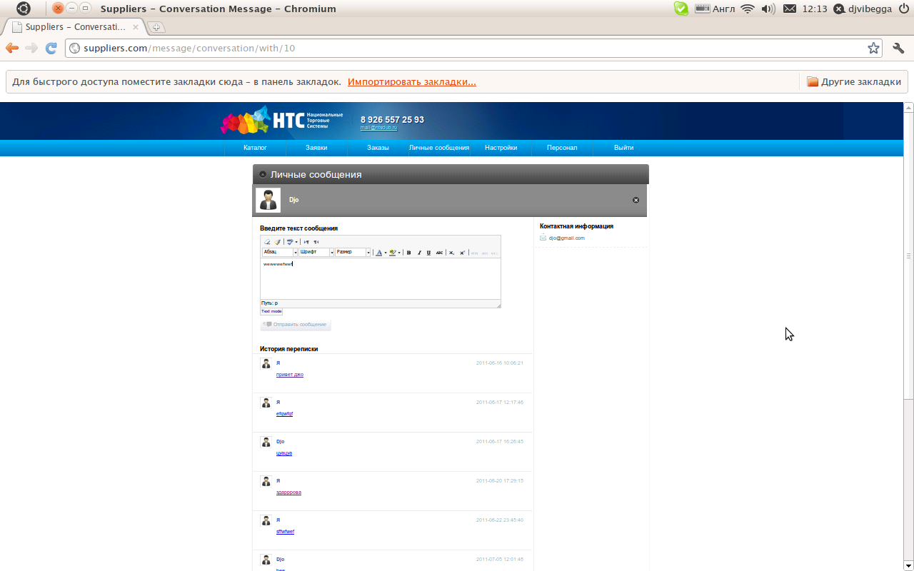
On this page you can send a message to another user, and view a complete history of correspondence. Unread messages are marked with special markers. The message list is automatically updated every 10 seconds without reloading the entire page.
2.3. Custumer Options
In this section, the user can access the following data:
2.3.1. Company Profile
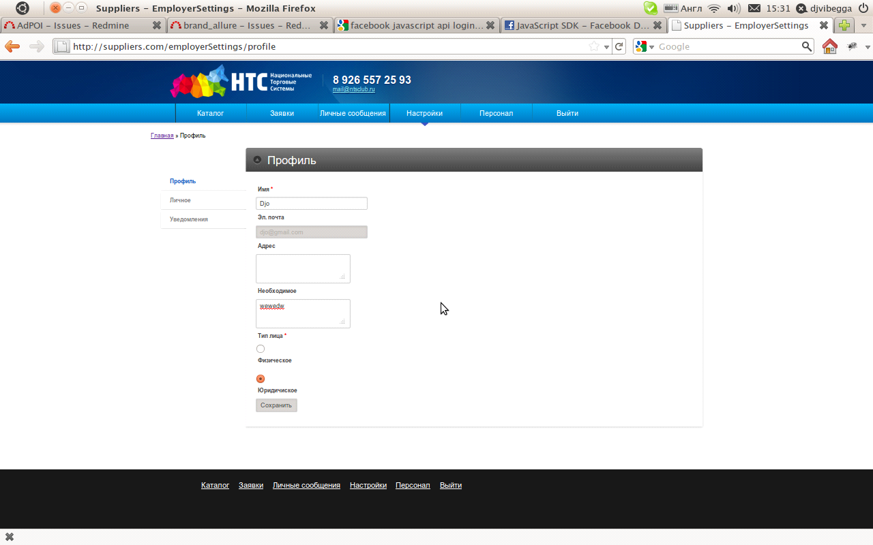
On this page you can change various characteristics of the profile of the company (legal account in general). Access to this page is only a "Custumer-manager."
2.3.2. Personal Settings
On this page you can change your personal information, such as: telephone, email, address, etc.
2.3.3. Notice to the custumer
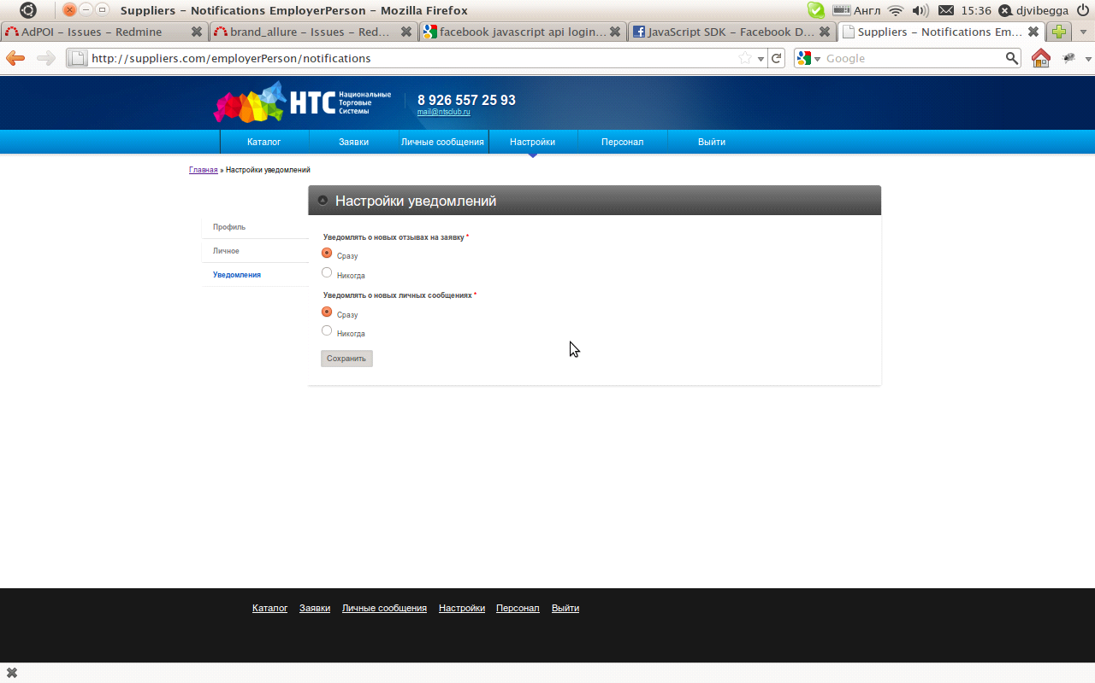
On this page you can set up filters for the notifications that come to him via email with various changes in the system.

2.4. HR Management
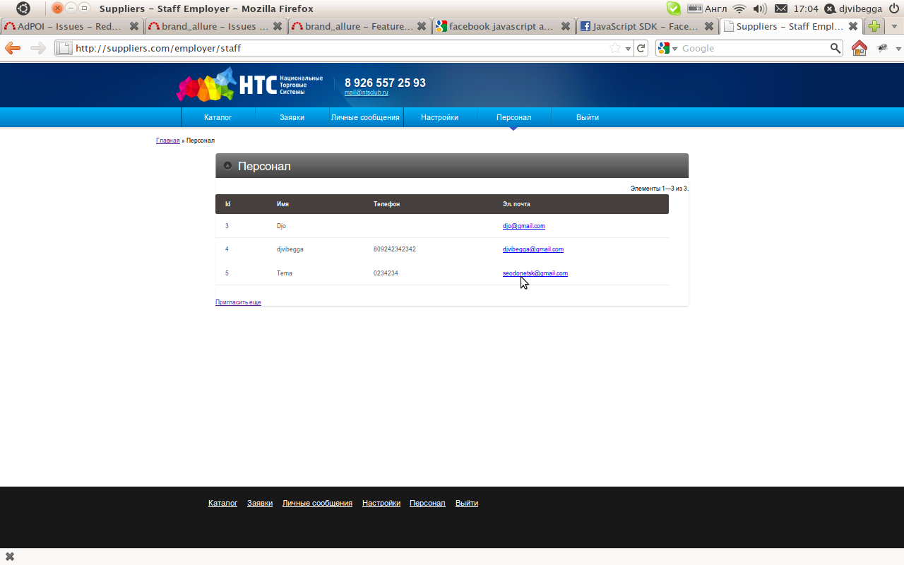
This page allows you to manage staff of the Custumer, you can invite a new employee into the system. At the invitation of the new user - he comes to be notified by email with a request to activate your account.

3. UI for suppliers
Suppliers are legal entities by default, so every account provider has staff. Accordingly, in the account provider are two podroli - "producer-manager" and "producer-worker '. For a "provider-admin" account is available all the "provider" and for "provider-employee" only - management applications and edit the personal information about yourself.
The list of options available to "Custumer":
- View directory of suppliers.
- Find the nearest supplier.
- Management applications.
- Personal communication.
- Settings.
- Staff.
3.1. Order Management
3.1.1. Management of orders to suppliers
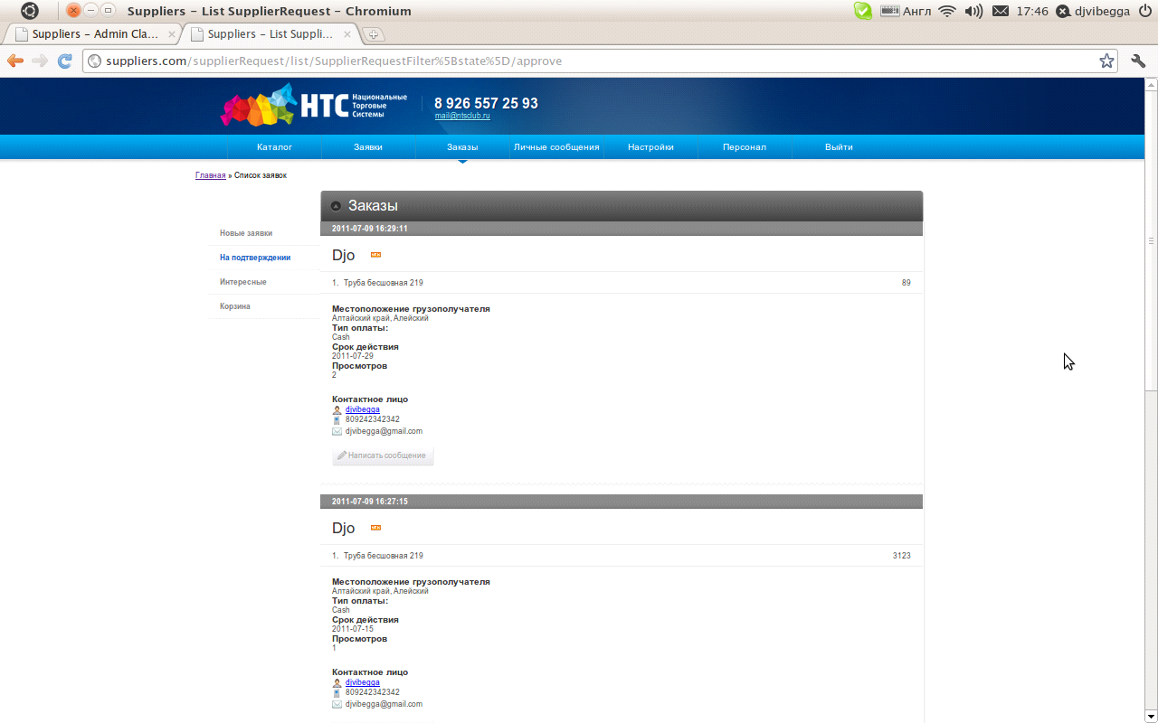

On this page, the provider can view a list of new applications received in the system that he can deliver. The user can move the order of "interesting" or "shopping cart" or to respond to a request:
Where the supplier indicates the price for which he can deliver the goods and his one user comment.
3.2 Private Messages
This section is identical for all registered users.
3.3. Provider settings
3.3.1. Company Profile Provider
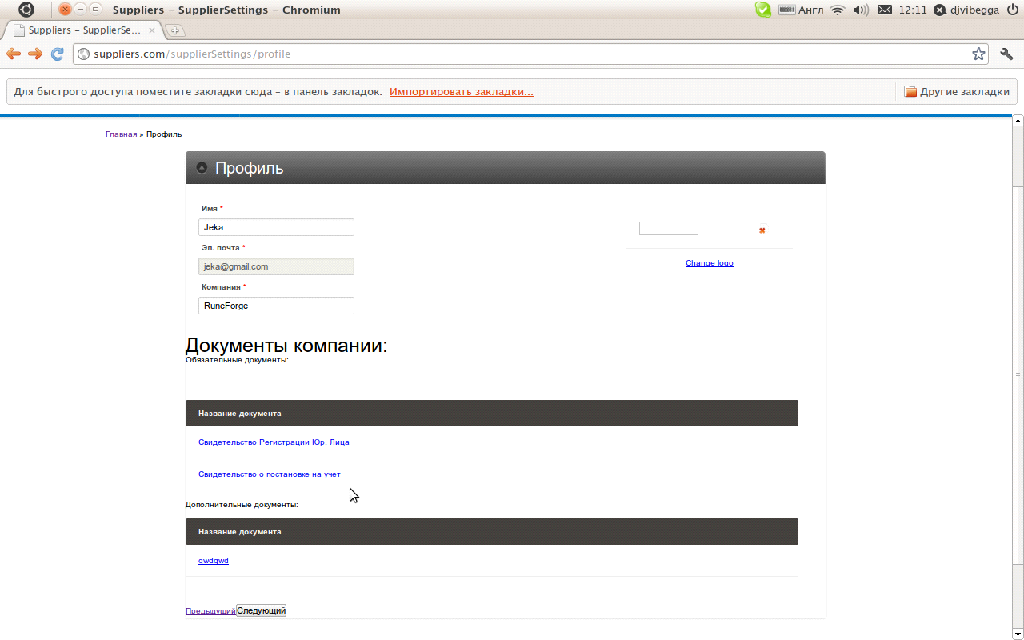
On this page "supplier-administrator" can fill the profile of the company, namely, its characteristics, to make binding documents, such as "certificate of registration of legal persons", "Certificate of Registration," etc. In addition to the mandatory documents can be downloaded limited number of non-binding instruments. Based on the information to fill out the profile system shall deduct the rating provider. Weighting factors for calculating rankings can change the "administrator" of the system.

3.3.2. Warehouse Locations
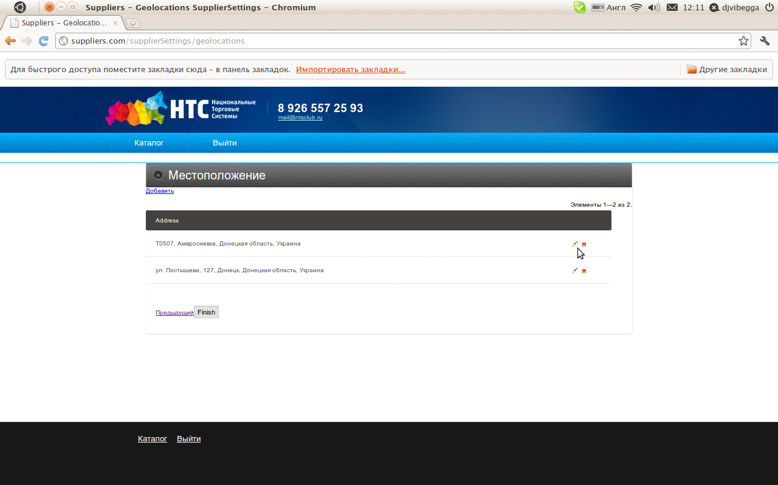
"Supplier-administrator" can add addresses of warehouses, each address of the warehouse, he points to the map Google Maps:
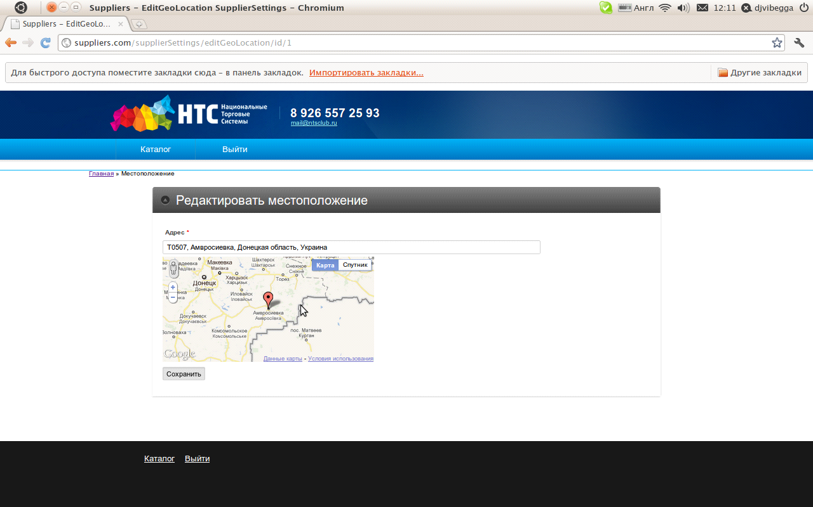

3.3.3. Personal Settings
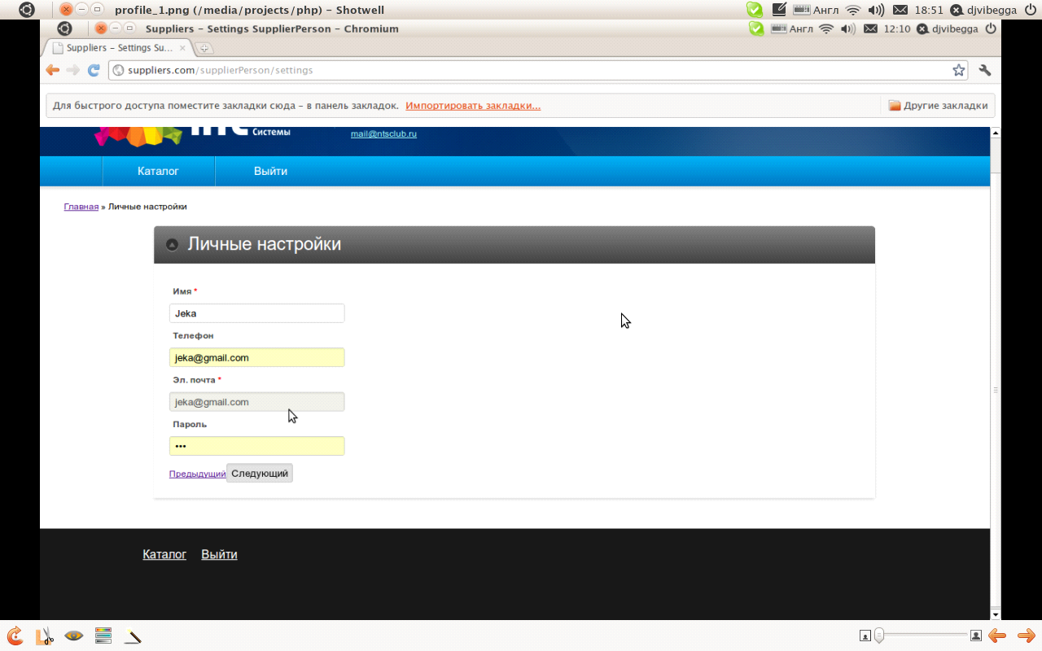
On this page "provider" can change the settings on your personal profile.
3.3.4. Interests of the company

On this page "supplier-administrator" can edit the interests of the company, namely the regions of interest and demand in the tree on the left to select products that he can deliver. On the left displays a tree of all available products, and right - all selected "supplier" of goods.
3.3.5. Notification Settings
On this page "supplier" can change your notification settings:
Notify on new Private Message.
Notify on new reviews on request.
Receive notification of new applications.
Notify the choice of the application, or reject the proposal.
Note: The first entry in the account are denied access to it a supplier to all pages except the settings that must be filled. Completing your account settings provider is in wizard mode.
3.3.6. Staff
The section "Personal" section works like "staff" for customers.
4 UI for admin
"Administrator" website edits only the most important settings, edit the general information available to all users and manages the feedback that comes from non-registered visitors (guests).
The list of options available to "Administrator":
Directory management products, the characteristics of the goods.
Managing custom-fields (custom properties).
Moderation reviews and complaints.
Setting weights for calculating the ratings for the accounts.
4.1. Office products
This screen shows the page management classifications for which the "administrator" looks at wood products (about 30000 products). The data loaded into the tree as needed (via AJAX). "Administrator" can create or edit an existing product, and add a new user to the product description. For example, "Steel": then when you add this product to request the Custumer will see this description and can choose from the dropdown list are interested in his "brand." Custom fields are created and configured, "Administrator" under "Custom Fields".
4.2. Manage custom fields
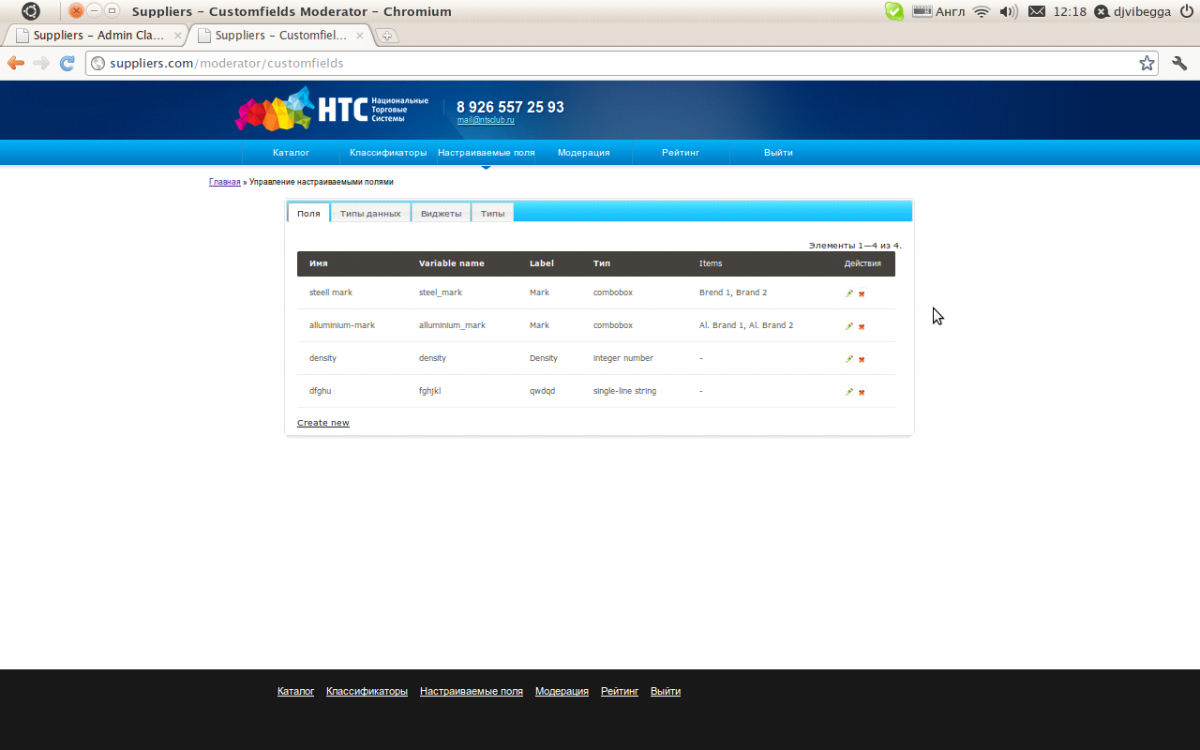
Above the screen displays a list of registered custom fields in the system. Below is a form to create / edit fields:
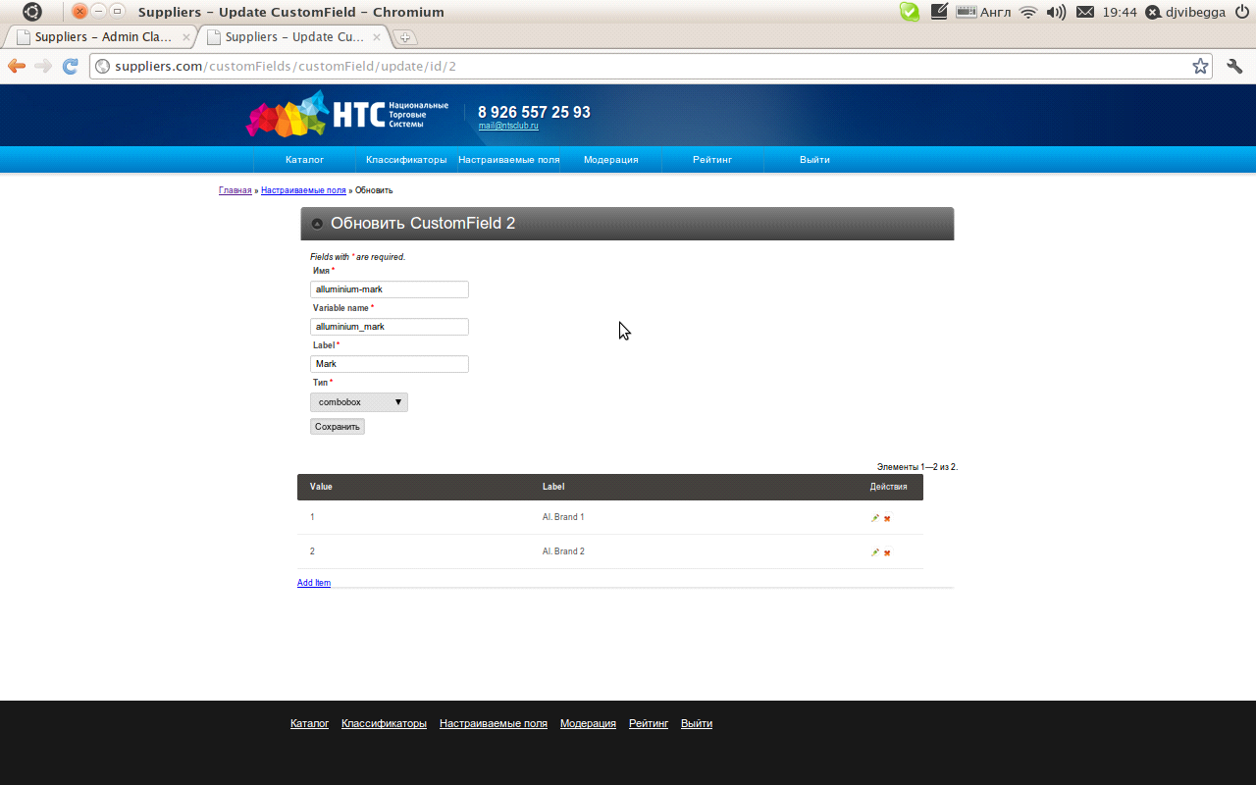
On this page an administrator creates a custom field, for example, "Mark began." However, he points out the following characteristics:
- Field name
- Label field (as it will be signed in the form of adding product).
- Variable name field (a variable name that will be used when editing the form template, add a product in the application).
- Type of field (drop-down list, single-line text, check, or any registered in the field type).

If the field type itemable (includes pre-defined list of possible values), then the edit form fields you can add, edit and delete any pre-determined value of the field (on-screen list of predefined values ​​displayed at the bottom).
To control the types of fields is a section "Field Types" for "Administrator"
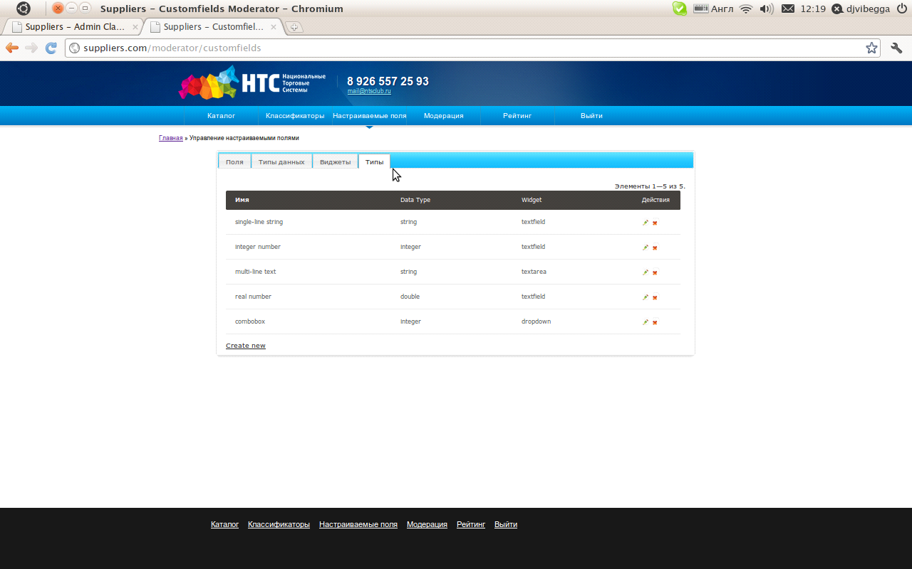
Where the "administrator" can create, edit or delete a field type. When you create a type of the field shall contain the following characteristics:
- Name field type
- Data type used to store values
- Type of widget used to display the fields in this type of form.
Naturally the "Administrator" can manage the types of data:
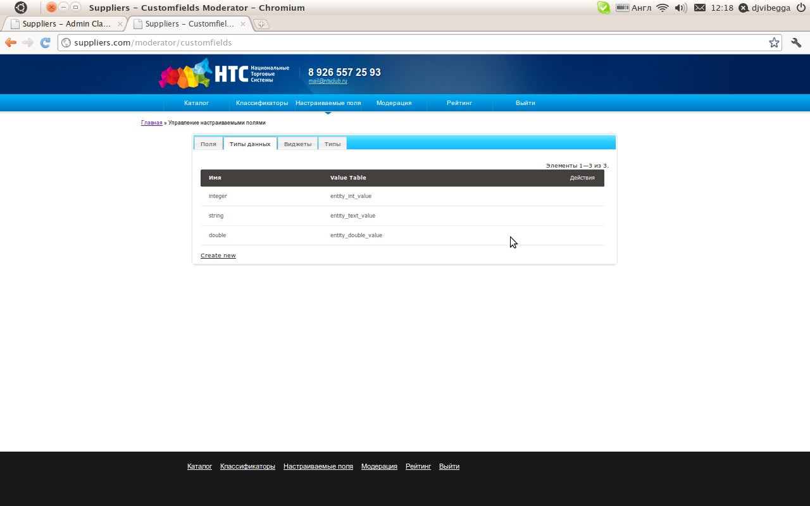
For each data type "Administrator" refers to the necessary characteristics: data type name in a database table to store the field values ​​of this type.
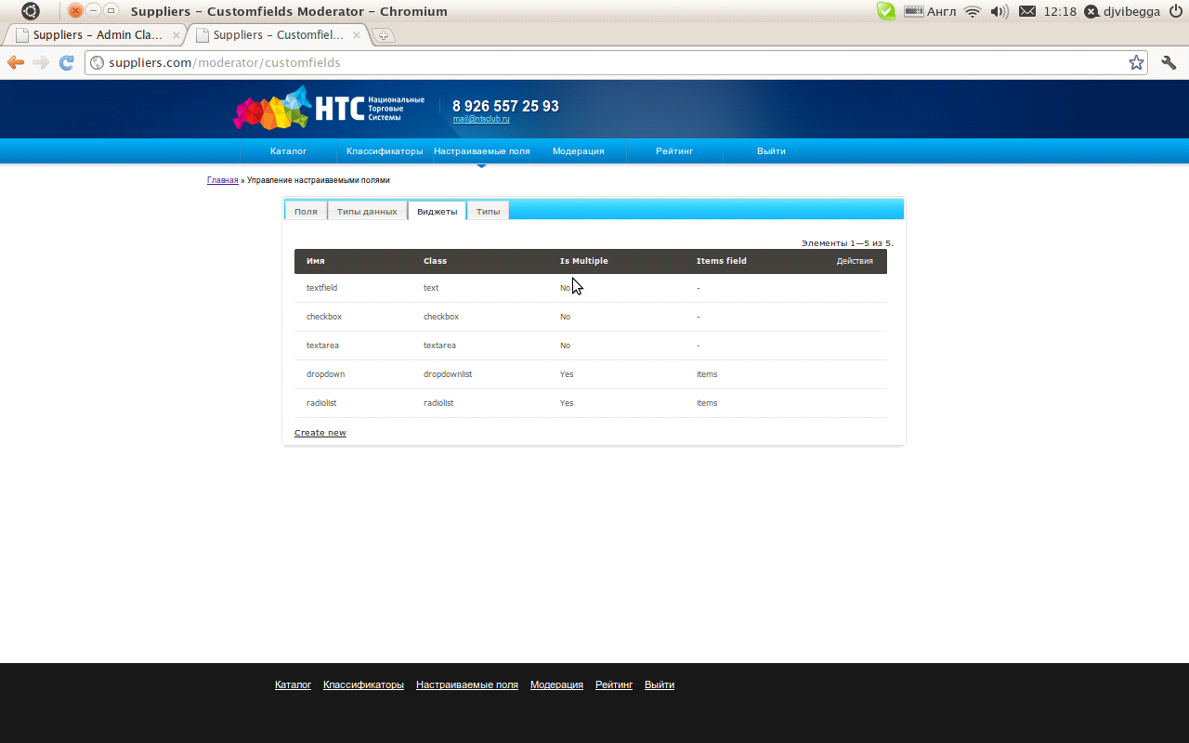
On the screen, which is shown above the "Administrator" can manage widgets to display custom fields. When creating or editing a widget are filled with the following characteristics:
- Widget name
- Class PHP, used to display the Widget
- Is there a widget elements.
- If the widget has elements, then the name field to store its elements in php (introduced in order to support third-party widgets developed for yii).

Form editing widget shown in the following screen:
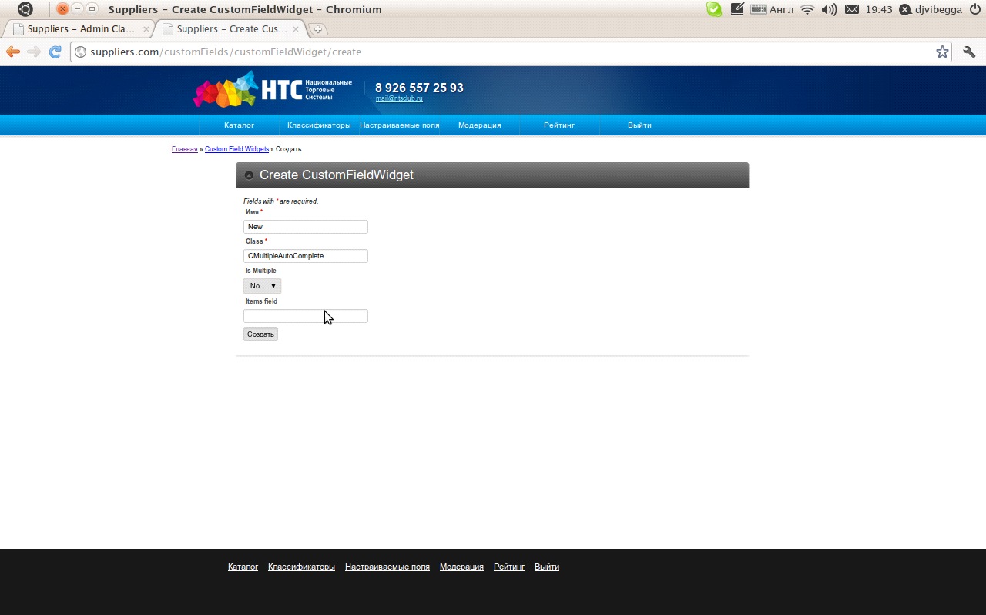
4.3. Moderation feedback and complaints
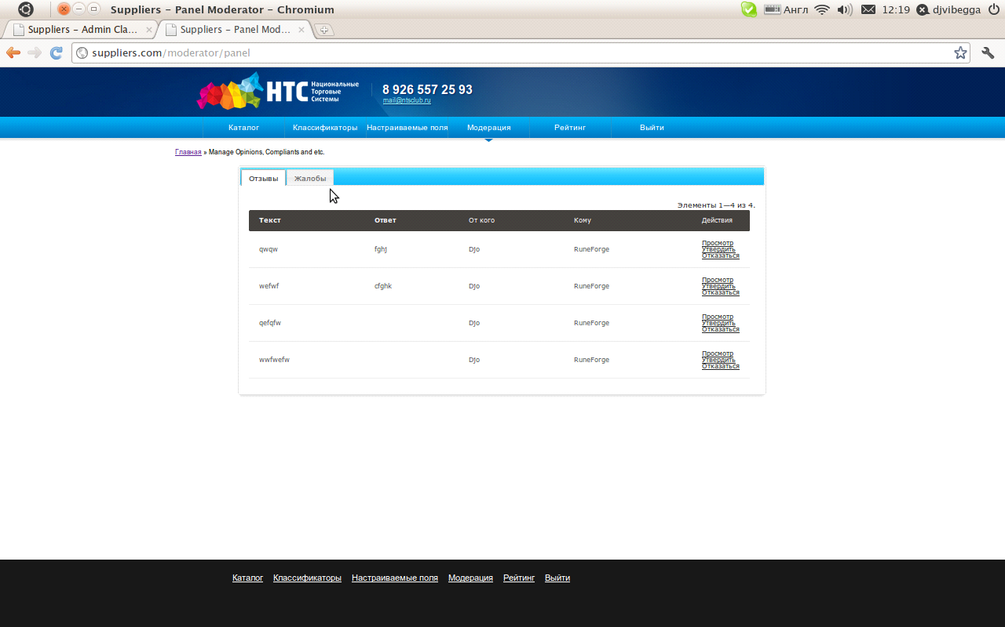
On this page the "Administrator" moderates reviews that come to accounts from the guests. "Administrator" can either confirm or deny review. Feedback is characterized by a voice message, and from -5 to 5.All confirmed reviewers involved in the calculation of the rating provider.
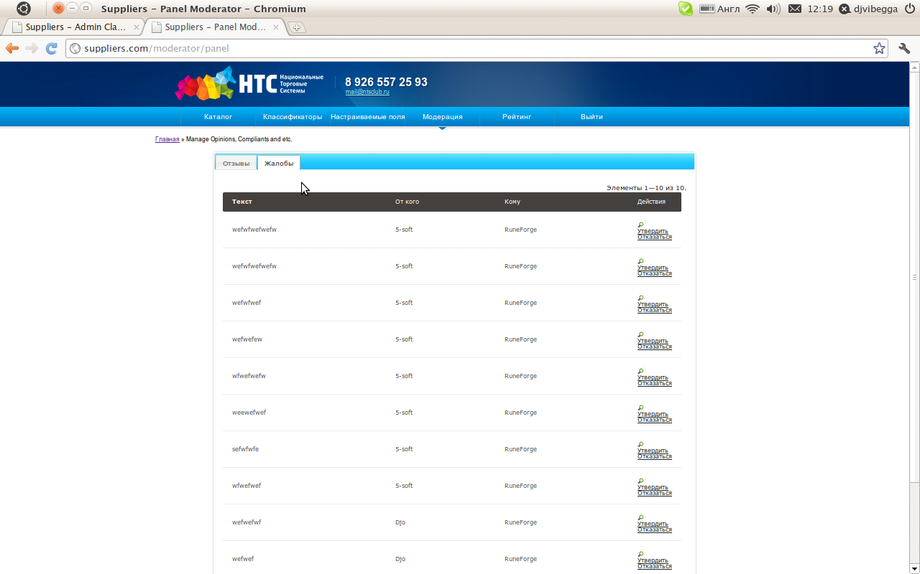
On this page the "Administrator" moderates complaints that come to the accounts of visitors. "Administrator" can either confirm or deny the complaint. All confirmed complaints of lower ranking vendor.
4.4. Setting ratings calculation
In addition to the moderation of complaints and feedback, "Administrator" can manage the calculation of the rating by editing the weights in the "Rating":
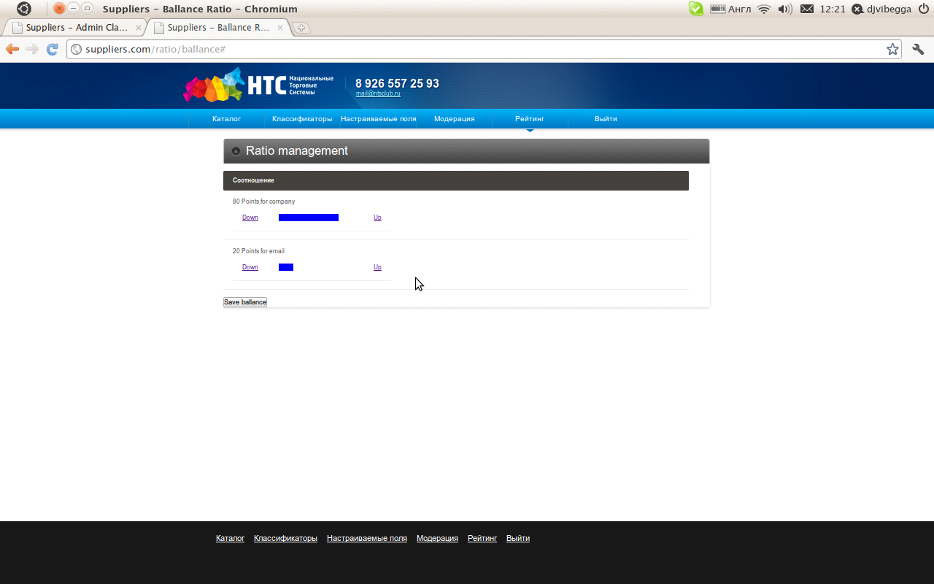
Pressing up or down it distributes the overall balance of rating points (100 points) on various characteristics.
5 What is common to all registered users
All registered users will see new personal message, they come in the form of pop-up of clouds in the upper right corner of the screen, as shown below:

